Lesson1 :Introduction
1.1 A brief description of Visual Basic
VISUAL BASIC is a high level programming language evolved from the earlier DOS version called BASIC. BASIC means Beginners' All-purpose Symbolic Instruction Code. It is a fairly easy programming language to learn. The codes look a bit like English Language. Different software companies produced different version of BASIC, such as Microsoft QBASIC, QUICKBASIC, GWBASIC ,IBM BASICA and so on.
VISUAL BASIC is a VISUAL and events driven Programming Language. These are the main divergence from the old BASIC. In BASIC, programming is done in a text-only environment and the program is executed sequentially. In VISUAL BASIC, programming is done in a graphical environment. Because users may click on a certain object randomly, so each object has to be programmed independently to be able to response to those actions (events). Therefore, a VISUAL BASIC Program is made up of many subprograms, each has its own program codes, and each can be executed independently and at the same time each can be linked together in one way or another.
1.2 The Visual Basic Environment
On start up, Visual Basic 6.0 will display the following dialog box as shown in figure 1.1.
You can choose to start a new project, open an existing project or select a list of recently opened programs. A project is a collection of files that make up your application. There are various types of applications we could create, however, we shall concentrate on creating Standard EXE programs (EXE means executable program). Now, click on the Standard EXE icon to go into the actual VB programming environment.
Figure 1.1 The Visual Basic Start-up Dialog Box
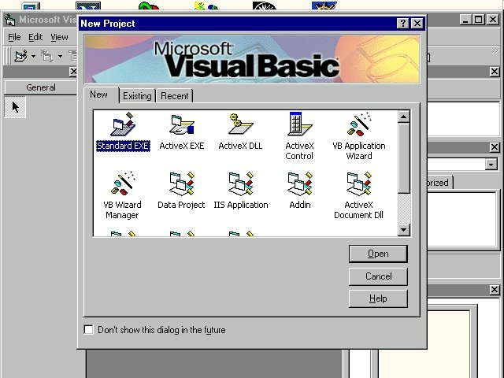
In figure 1.2, the Visual Basic Environment consists of the:
- A Blank Form for you to design your application's interface.
- The Project window which displays the files that are created in your application.
- The Properties window which displays the properties of various controls and objects that are created in your applications.
It also includes a Toolbox that consists of all the controls essential for developing a VB Application. Controls are tools such as text box, command button, label, combo box, picture box, image box, timer and other objects that can be dragged and drawn on a form to perform certain tasks according to the events associated with them. Additional objects can be added by clicking on the project item on the menu and click on components on the drop-down list, then select those controls you need to use in your program
Figure 1.2: The Visual Basic Enviroment
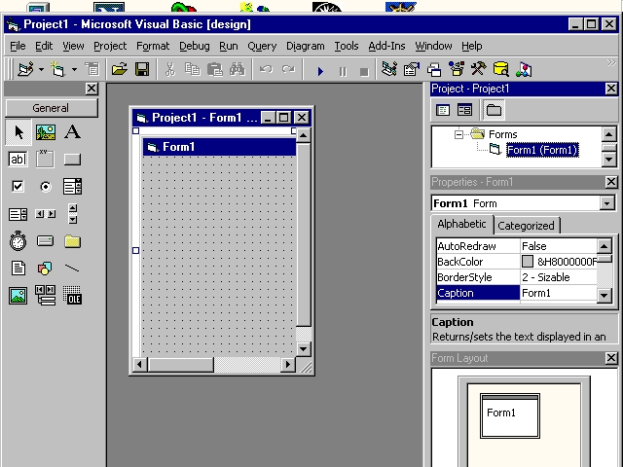

Lesson 2: Building a Visual Basic Application

2.1 Creating Your First Application

In this section, we are not going into the technical aspects of VB programming; just have a feel of it. Now, you can try out the examples below:

Example 2.1.1 is a simple program. First of all, you have to launch Microsoft Visual Basic. Normally, a default form Form1 will be available for you to start your new project. Now, double click on form1, the source code window for form1 as shown in figure 2.1 will appear. The top of the source code window consists of a list of objects and their associated events or procedures. In figure 2.1, the object displayed is Form and the associated procedure is Load.

Figure 2.1 Source Code Window
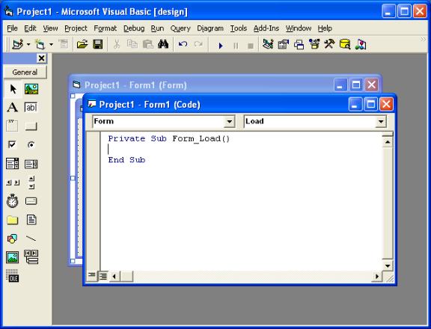

When you click on the object box, the drop-down list will display a list of objects you have inserted into your form as shown in figure 2.2. Here, you can see a form, command button with the name Command1, a Label with the name Label1 and a PictureBox with the name Picture1. Similarly, when you click on the procedure box, a list of procedures associated with the object will be displayed as shown in figure 2.3. Some of the procedures associated with the object Form are Activate, Click, DblClick (which means Double-Click) , DragDrop, keyPress and etc. Each object has its own set of procedures. You can always select an object and write codes for any of its procedure in order to perform certain tasks.

Figure 2.2: List of Objects
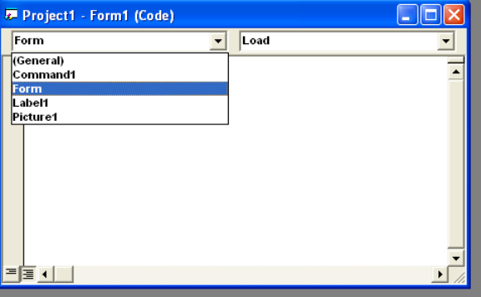

Figure 2.3: List of Procedures
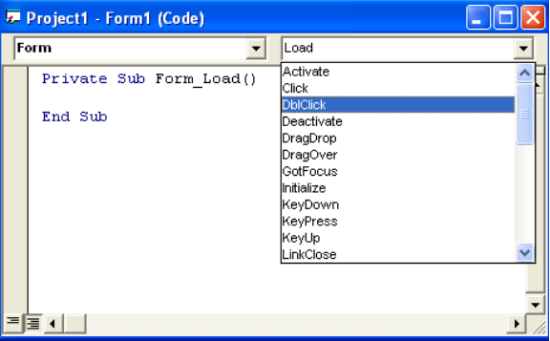

You do not have to worry about the beginning and the end statements (i.e. Private Sub Form_Load.......End Sub.); Just key in the lines in between the above two statements exactly as are shown here. When you run the program, you will be surprise that nothing shown up .In order to display the output of the program, you have to add the Form1.show statement like in Example 2.1.1 or you can just use Form_Activate ( ) event procedure as shown in example 2.1.2. The command Print does not mean printing using a printer but it means displaying the output on the computer screen. Now, press F5 or click on the run button to run the program and you will get the output as shown in figure 2.4.

Example 2.1.1
Private Sub Form_Load ( )
Form1.show
Print “Welcome to Visual Basic tutorial”
End Sub

Figure 2.4 : The output of example 2.1.1
. 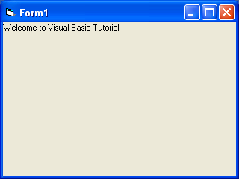

You can also perform simple arithmetic calculations as shown in example 2.1.2. VB uses * to denote the multiplication operator and / to denote the division operator. The output is shown in figure 2.3, where the results are arranged vertically.

Example 2.1.2
Private Sub Form_Activate ( )
Print 20 + 10
Print 20 - 10
Print 20 * 10
Print 20 / 10
End Sub

Figure 2.5: The output of example 2.1.2
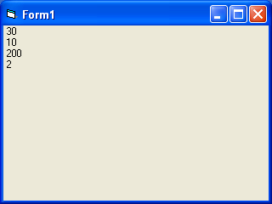

Example 2.1.2 can also be written as
Private Sub Form_Activate ( )
Print 20 + 10, 20 – 10, 20 * 10, 20 / 10
End Sub
The numbers will be arranged in a horizontal line separated by spaces as shown in figure 2.6

Figure 2.6: Output in a horizontal line
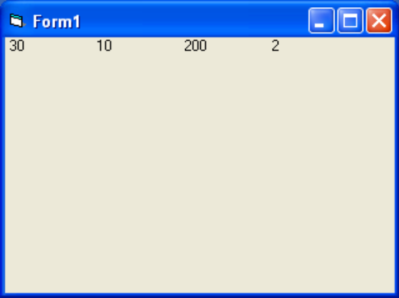
Example 2.1.3 is an improved version of example 2.1.2 as it employs two variables x and y and assigned initial values of 20 and 10 to them respectively. When you need to change the values of x and y, just change the initial values rather than changing every individual value which is more time consuming.

Example 2.1.3
Private Sub Form_Activate ( )
x = 20
y = 10
Print x + y
Print x - y
Print x * y
Print x / y
End Sub

Besides, you can also use the + or the & operator to join two or more texts (string) together like in example 2.1.4 (a) and (b)
Example 2.1.4(b)

Private Sub Form_Activate()
A = "Tom"
B = “likes"
C = “to"
D = “eat"
E = “burger"
Print A & B & C & D & E
End Sub

Example 2.1.4(a)
Private Sub Form_Activate( )
A = "Tom"
B = “likes"
C = “to"
D = “eat"
E = “burger"
Print A + B + C + D + E
End Sub

The output is as shown in figure 2.7

Figure 2.7: The Output of Example 2.1.4(a) &(b)
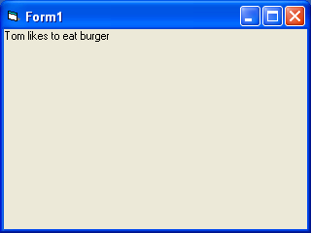

2.2 Steps in Building a Visual Basic Application

Generally, there are three basic steps in building a VB application. The steps are as follows:
Step 1 : Design the interface
Step 2 : Set Properties of the controls (Objects)
Step 3 : Write the events' procedures

Example 2.2.1
This program is a simple program that calculates the volume of a cylinder. Let design the interface:

Figure 2.8 A program to calculate the Volume of a Cylinder
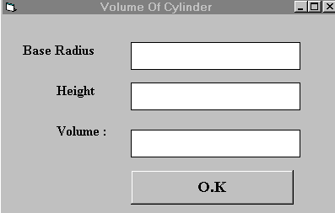

First of all, go to the properties window and change the form caption to Volume of Cylinder, then drag and insert three labels into the form and change their captions to Base Radius, height and volume respectively. After that, insert three Text Boxes and clear its text contents so that you get three empty boxes. Named the text boxes as radius, hght (we cannot use height as it is the built-in control name of VB) and volume respectively. Lastly, insert a command button and change its caption to O.K and its name to OK. Now save the project as cylinder.vbp and the form as cylinder.vbp as well. We shall leave out the codes at the moment which you shall learn it in lesson3.

Example 2.2.2

Designing an attractive and user friendly interface should be the first step in constructing a VB program. To illustrate, let's look at the calculator program.
Figure 2.9: Calculator
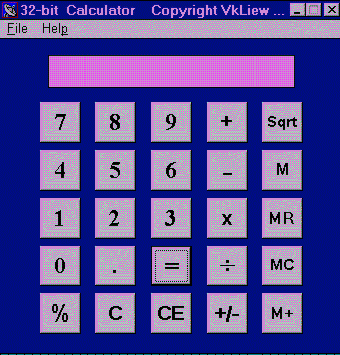

Now, follow the steps below to design the calculator interface.
- Resize the form until you get the size you are satisfied with.
- Go to the properties window and change the default caption to the caption you want, such as 32 Calculator.
- Change other properties of the form, such as background color, foreground color, border style. I recommend you set the following properties for Form1 for this calculator program:

BorderStyle | Fixed Single
MaxButton | False
minButton | True

These properties will ensure that the users cannot resize or maximize your calculator window, but able to minimize the window.
- Draw the Display Panel by clicking on the Label button and and place your mouse on the form. Start drawing by pressing down your mouse button and drag it along.
- Click on the panel and the corresponding properties window will appear. Clear the default label so that the caption is blank (because the display panel is supposed to show the number as we click on the number button). It is better to set the background color to a bright color while the foreground color should be something like black (for easy viewing). Change the name to display as I am going to use it later to write codes for the calculator.
- Now draw the command buttons that are necessary to operate a calculator. I suggest you follow exactly what is shown in the image above.

Now run the project by pressing F5. If you are satisfied with the appearance, go ahead to save the project. At the same time, you should also save the file that contains your form.

Here are other interesting Interfaces, such as a slot machine as shown in figure 2.1

Figure 2.10 Slot Machine
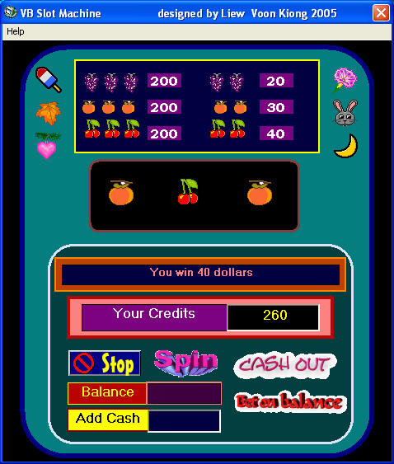

or a snake and ladder chess as shown in figure 2.2
Figure 2.11 Snake and Ladder Chess
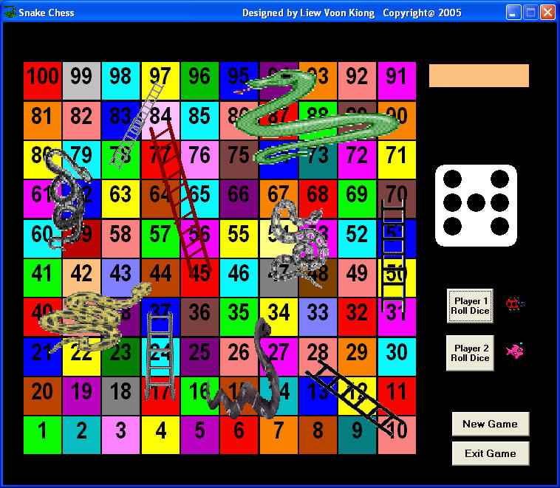

Lesson 3-Working With Controls

Lesson 3 Working with Controls
3.1 The Control Properties
Before writing an event procedure for the control to response to a user's input, you have to set certain properties for the control to determine its appearance and how it will work with the event procedure. You can set the properties of the controls in the properties window or at runtime.
Figure 3.1 on the right is a typical properties window for a form. You can rename the form caption to any name that you like best. In the properties window, the item appears at the top part is the object currently selected (in Figure 3.1, the object selected is Form1). At the bottom part, the items listed in the left column represent the names of various properties associated with the selected object while the items listed in the right column represent the states of the properties. Properties can be set by highlighting the items in the right column then change them by typing or selecting the options available. For example, in order to change the caption, just highlight Form1 under the name Caption and change it to other names. You may also try to alter the appearance of the form by setting it to 3D or flat. Other things you can do are to change its foreground and background color, change the font type and font size, enable or disable minimize and maximize buttons and etc.  You can also change the properties at runtime to give special effects such as change of color, shape, animation effect and so on. For example the following code will change the form color to red every time the form is loaded. VB uses hexadecimal system to represent the color. You can check the color codes in the properties windows which are showed up under ForeColor and BackColor .  Private Sub Form_Load()  Form1.Show  Form1.BackColor = &H000000FF&  End Sub | Figure 3.1  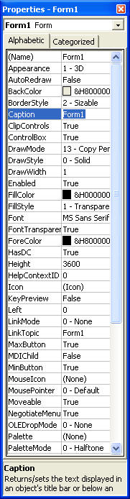
Another example is to change the control Shape to a particular shape at runtime by writing the following code. This code will change the shape to a circle at runtime. Later you will learn how to change the shapes randomly by using the RND function.
Private Sub Form_Load()
Shape1.Shape = 3
End Sub
I would like to stress that knowing how and when to set the objects' properties is very important as it can help you to write a good program or you may fail to write a good program. So, I advice you to spend a lot of time playing with the objects' properties.
I am not going into the details on how to set the properties. However, I would like to stress a few important points about setting up the properties.
- You should set the Caption Property of a control clearly so that a user knows what to do with that command. For example, in the calculator program, all the captions of the command buttons such as +, - , MC, MR are commonly found in an ordinary calculator, a user should have no problem in manipulating the buttons.
- A lot of programmers like to use a meaningful name for the Name Property may be because it is easier for them to write and read the event procedure and easier to debug or modify the programs later. However, it is not a must to do that as long as you label your objects clearly and use comments in the program whenever you feel necessary. T
- One more important property is whether the control is enabled or not.
- Finally, you must also considering making the control visible or invisible at runtime, or when should it become visible or invisible.

3.2 Handling some of the common controls
3.2.1 The Text Box
The text box is the standard control that is used to receive input from the user as well as to display the output. It can handle string (text) and numeric data but not images or pictures. String in a text box can be converted to a numeric data by using the function Val(text). The following example illustrates a simple program that processes the inputs from the user.

Example 3.1
In this program, two text boxes are inserted into the form together with a few labels. The two text boxes are used to accept inputs from the user and one of the labels will be used to display the sum of two numbers that are entered into the two text boxes. Besides, a command button is also programmed to calculate the sum of the two numbers using the plus operator. The program use creates a variable sum to accept the summation of values from text box 1 and text box 2.The procedure to calculate and to display the output on the label is shown below. The output is shown in Figure 3.1.
Private Sub Command1_Click()
‘To add the values in text box 1 and text box 2
Sum = Val(Text1.Text) + Val(Text2.Text)
‘To display the answer on label 1
Label1.Caption = Sum
End Sub
Figure 3.1
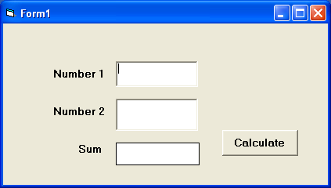

3.2.2 The Label
The label is a very useful control for Visual Basic, as it is not only used to provide instructions and guides to the users, it can also be used to display outputs. One of its most important properties is Caption. Using the syntax label.Caption, it can display text and numeric data . You can change its caption in the properties window and also at runtime. Please refer to Example 3.1 and Figure 3.1 for the usage of label.
3.2.3 The Command Button
The command button is a very important control as it is used to execute commands. It displays an illusion that the button is pressed when the user click on it. The most common event associated with the command button is the Click event, and the syntax for the procedure is
Private Sub Command1_Click ()
Statements
End Sub
3.2.4 The Picture Box
The Picture Box is one of the controls that used to handle graphics. You can load a picture at design phase by clicking on the picture item in the properties window and select the picture from the selected folder. You can also load the picture at runtime using the LoadPicture method. For example, the statement will load the picture grape.gif into the picture box.
Picture1.Picture=LoadPicture ("C:\VB program\Images\grape.gif")
You will learn more about the picture box in future lessons. The image in the picture box is not resizable.

3.2.5 The Image Box
The Image Box is another control that handles images and pictures. It functions almost identically to the picture box. However, there is one major difference, the image in an Image Box is stretchable, which means it can be resized. This feature is not available in the Picture Box. Similar to the Picture Box, it can also use the LoadPicture method to load the picture. For example, the statement loads the picture grape.gif into the image box.
Image1.Picture=LoadPicture ("C:\VB program\Images\grape.gif")

3.2.6 The List Box
The function of the List Box is to present a list of items where the user can click and select the items from the list. In order to add items to the list, we can use the AddItem method. For example, if you wish to add a number of items to list box 1, you can key in the following statements
Example 3.2
Private Sub Form_Load ( )
List1.AddItem “Lesson1”
List1.AddItem “Lesson2”
List1.AddItem “Lesson3”
List1.AddItem “Lesson4”
End Sub
The items in the list box can be identified by the ListIndex property, the value of the ListIndex for the first item is 0, the second item has a ListIndex 1, and the second item has a ListIndex 2 and so on
3.2.7 The Combo Box
The function of the Combo Box is also to present a list of items where the user can click and select the items from the list. However, the user needs to click on the small arrowhead on the right of the combo box to see the items which are presented in a drop-down list. In order to add items to the list, you can also use the AddItem method. For example, if you wish to add a number of items to Combo box 1, you can key in the following statements
Example 3.3
Private Sub Form_Load ( )
Combo1.AddItem “Item1”
Combo1.AddItem “Item2”
Combo1.AddItem “Item3”
Combo1.AddItem “Item4”
End Sub

3.2.8 The Check Box
The Check Box control lets the user to select or unselect an option. When the Check Box is checked, its value is set to 1 and when it is unchecked, the value is set to 0. You can include the statements Check1.Value=1 to mark the Check Box and Check1.Value=0 unmark the Check Box, and use them to initiate certain actions. For example, the program will change the background color of the form to red when the check box is unchecked and it will change to blue when the check box is checked. You will learn about the conditional statement If….Then….Elesif in later lesson. VbRed and vbBlue are color constants and BackColor is the background color property of the form.

Example 3.4
Private Sub Check1_Click ()
If Check1.Value = 0 Then
Form1.BackColor = vbRed
ElseIf Check1.Value = 1 Then
Form1.BackColor = vbBlue
End If
End Sub

3.2.9 The Option Box

The Option Box control also lets the user selects one of the choices. However, two or more Option Boxes must work together because as one of the Option Boxes is selected, the other Option Boxes will be unselected. In fact, only one Option Box can be selected at one time. When an option box is selected, its value is set to “True” and when it is unselected; its value is set to “False”. In the following example, the shape control is placed in the form together with six Option Boxes. When the user clicks on different option boxes, different shapes will appear. The values of the shape control are 0, 1, and 2,3,4,5 which will make it appear as a rectangle, a square, an oval shape, a rounded rectangle and a rounded square respectively.
Example 3.5
Private Sub Option1_Click ( )
Shape1.Shape = 0
End Sub
Private Sub Option2_Click()
Shape1.Shape = 1
End Sub
Private Sub Option3_Click()
Shape1.Shape = 2
End Sub
Private Sub Option4_Click()
Shape1.Shape = 3
End Sub
Private Sub Option5_Click()
Shape1.Shape = 4
End Sub
Private Sub Option6_Click()
Shape1.Shape = 5
End Sub
3.2.9 The Drive List Box
The Drive ListBox is used to display a list of drives available in your computer. When you place this control into the form and run the program, you will be able to select different drives from your computer as shown in Figure 3.2
Figure 3.2 The Drive List Box
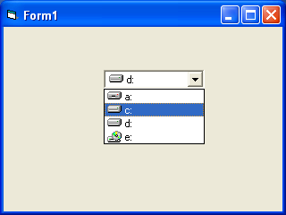
3.2.10 The Directory List Box
The Directory List Box is used to display the list of directories or folders in a selected drive. When you place this control into the form and run the program, you will be able to select different directories from a selected drive in your computer as shown in Figure 3.3
Figure 3.3 The Directory List Box
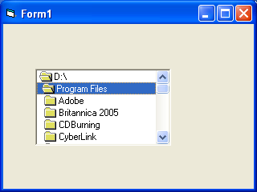

3.2.11 The File List Box
The File List Box is used to display the list of files in a selected directory or folder. When you place this control into the form and run the program, you will be able to a list of files in a selected directory as shown in Figure 3.4
Figure 3.4
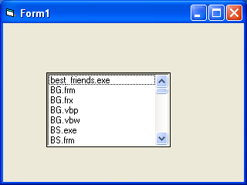
You can coordinate the Drive List Box, the Directory List Box and the File List Box to search for the files you want. The procedure will be discussed in later lessons.

Lesson 4 Writing the Codes
In lesson 2, you have learned how to enter the program code and run the sample VB programs but without much understanding about the logics of VB programming. Now, let’s get down learning a few basic rules about writing the VB program code.
Each control or object in VB can usually run many kinds of events or procedures; these events are listed in the dropdown list in the code window that is displayed when you double-click on an object and click on the procedures’ box(refer to Figure 2.3). Among the events are loading a form, clicking of a command button, pressing a key on the keyboard or dragging an object and etc. For each event, you need to write an event procedure so that an action or a series of actions can be performed.
To start writing an event procedure, you need to double-click an object. For example, if you want to write an event procedure when a user clicks a command button, you double-click on the command button and an event procedure will appear as shown in Figure 2.1. It takes the following format:

Private Sub Command1_Click
(Key in your program code here)

End Sub
You then need to key-in the procedure in the space between Private Sub Command1_Click............. End Sub. Sub actually stands for sub procedure that made up a part of all the procedures in a program. The program code is made up of a number of statements that set certain properties or trigger some actions. The syntax of Visual Basic’s program code is almost like the normal English language though not exactly the same, so it is very easy to learn.
The syntax to set the property of an object or to pass certain value to it is :
Object.Property
where Object and Property is separated by a period (or dot). For example, the statement Form1.Show means to show the form with the name Form1, Iabel1.Visible=true means label1 is set to be visible, Text1.text=”VB” is to assign the text VB to the text box with the name Text1, Text2.text=100 is to pass a value of 100 to the text box with the name text2, Timer1.Enabled=False is to disable the timer with the name Timer1 and so on. Let’s examine a few examples below:

Example 4.1
Private Sub Command1_click
Label1.Visible=false
Label2.Visible=True
Text1.Text=”You are correct!”
End sub

Example 4.2
Private Sub Command1_click
Label1.Caption=” Welcome”
Image1.visible=true
End sub

Example 4.3
Private Sub Command1_click
Pictuire1.Show=true
Timer1.Enabled=True
Lable1.Caption=”Start Counting
End sub
In example 4.1, clicking on the command button will make label1 become invisible and label2 become visible; and the text” You are correct” will appear in TextBox1. In example 4.2, clicking on the command button will make the caption label1 change to “Welcome” and Image1 will become visible. Example, clicking on the command button will make Picture1 show up, timer starts running and the caption of label1 change to “Start Counting”.
Syntaxes that do not involve setting of properties are also English-like, some of the commands are Print, If…Then….Else….End If, For…Next, Select Case…..End Select , End and Exit Sub. For example, Print “ Visual Basic” is to display the text Visual Basic on screen and End is to end the program. Other commands will be explained in details in the coming lessons.
Program codes that involve calculations is very easy to write, you need to write them almost liket what you do in mathematics. However, in order to write an event procedure that involves calculations, you need to know the basic arithmetic operators in VB as they are not exactly the same as the normal operators we use, except for + and - . For multiplication, we use *, for division we use /, for raising a number x to the power of n, we use x ^n and for square root, we use Sqr(x). More advanced mathematical functions such as Sin, Cos, Tan , Log and etc. There are also two important functions that are related to arithmetic operations, i.e. the functions Val and Str$ where Val is to convert text entered into a textbox to numerical value and Str$ is to display a numerical value in a textbox as a string (text). While the function Str$ is as important as VB can display a numeric values as string implicitly, failure to use Val will results in wrong calculation. Let’s examine example 4.4 and example 4.5.

Example 4.4
Private Sub Form_Activate()
Text3.text=text1.text+text2.text
End Sub
Example 4.5
Private Sub Form_Activate()
Text3.text=val(text1.text)+val(text2.text)
End Sub
When you run the program in example 4.4 and enter 12 in textbox1 and 3 in textbox2 will give you a result of 123, which is wrong. It is because VB treat the numbers as string and so it just joins up the two strings. On the other hand, running exampled 4.5 will give you the correct result, i.e., 15.
We shall now look at more examples in mathematics.
Now we shall attempt to write the codes for the cylinder program where the interface is shown in Figure 2.8. First of all, name the textbox as radius, hght, and volume. To get the values of the various textboxes, use Val(radius.text), Val(hght.Text) and assign them to the variables r and h. In addition, assign the value 22/7 to the variable pi. After that, write the equation v = pi * (r ^ 2) * h to compute the value of volume of cylinder and then assign it to the variable v. Finally, display the value in the volume textbox using the function Str$.
Private Sub OK_Click( )
r = Val(radius.Text)
h = Val(hght.Text)
pi = 22 / 7
v = pi * (r ^ 2) * h
volume.Text= Str$(v)
End Sub
When you run the program, you should be able to see the interface as shown in Figure 2.8. If you enter a value each in the radius box and the height box, then click OK; the value of the Volume will be displayed in the volume box.
I shall attempt to explain the above source program to newcomers in Visual Basic ( If you are a veteran, you can skip this part) . The program could be explained using pseudo codes as follows:
Procedure for clicking the OK button to calculate the volume of cylinder
get the value of r from the radius text box
get the value of h from the height text box
assign a constant value 22/7 to pi
calculate the volume using formula
output the results to the Volume text box
End of Procedure
Exercise 4

- Write a program to compute an area of a triangle.
Write a program to calculate the circumference and area of a circle

Lesson 5: Managing Visual Basic Data
There are many types of data we come across in our daily life. For example, we need to handle data such as names, addresses, money, date, stock quotes, statistics and etc everyday. Similarly in Visual Basic, we are also going to deal with these kinds of data. However, to be more systematic, VB divides data into different types.
5.1 Types of Visual Basic Data
5.1.1 Numeric Data
Numeric data are data that consists of numbers, which can be computed mathematically with various standard operators such as add, minus, multiply, divide and so on. In Visual Basic, the numeric data are divided into 7 types, they are summarized in Table 5.1
Table 5.1: Numeric Data Types

Type | Storage | Range of Values
Byte | 1 byte | 0 to 255
Integer | 2 bytes | -32,768 to 32,767
Long | 4 bytes | -2,147,483,648 to 2,147,483,648
Single | 4 bytes | -3.402823E+38 to -1.401298E-45 for negative values  1.401298E-45 to 3.402823E+38 for positive values.
Double | 8 bytes | -1.79769313486232e+308 to -4.94065645841247E-324 for negative values  4.94065645841247E-324 to 1.79769313486232e+308 for positive values.
Currency | 8 bytes | -922,337,203,685,477.5808 to 922,337,203,685,477.5807
Decimal | 12 bytes | +/- 79,228,162,514,264,337,593,543,950,335 if no decimal is use  +/- 7.9228162514264337593543950335 (28 decimal places).
5.1.2 Non-numeric Data Types
the nonnumeric data types are summarized in Table 5.2
Table 5.2: Nonnumeric Data Types
Data Type | Storage | Range
String(fixed length) | Length of string | 1 to 65,400 characters
String(variable length) | Length + 10 bytes | 0 to 2 billion characters
Date | 8 bytes | January 1, 100 to December 31, 9999
Boolean | 2 bytes | True or False
Object | 4 bytes | Any embedded object
Variant(numeric) | 16 bytes | Any value as large as Double
Variant(text) | Length+22 bytes | Same as variable-length string
5.1.3 Suffixes for Literals
Literals are values that you assign to a data. In some cases, we need to add a suffix behind a literal so that VB can handle the calculation more accurately. For example, we can use num=1.3089# for a Double type data. Some of the suffixes are displayed in Table 5.3.
Table 5.3

Suffix | Data Type
& | Long
! | Single
# | Double
@ | Currency
In addition, we need to enclose string literals within two quotations and date and time literals within two # sign. Strings can contain any characters, including numbers. The following are few examples:
memberName="Turban, John."
TelNumber="1800-900-888-777"
LastDay=#31-Dec-00#
ExpTime=#12:00 am#
5.2 Managing Variables
Variables are like mail boxes in the post office. The contents of the variables changes every now and then, just like the mail boxes. In term of VB, variables are areas allocated by the computer memory to hold data. Like the mail boxes, each variable must be given a name. To name a variable in Visual Basic, you have to follow a set of rules.
5.2.1 Variable Names
The following are the rules when naming the variables in Visual Basic
- It must be less than 255 characters
- No spacing is allowed
- It must not begin with a number
- Period is not permitted
Examples of valid and invalid variable names are displayed in Table 5.4
Table 5.4
Valid Name | Invalid Name
My_Car | My.Car
ThisYear | 1NewBoy
Long_Name_Can_beUSE | He&HisFather *& is not acceptable

5.2.2 Declaring Variables
In Visual Basic, one needs to declare the variables before using them by assigning names and data types. They are normally declared in the general section of the codes' windows using the Dim statement.
The format is as follows:
Dim variableNmae as DataType
Example 5.1
Dim password As String
Dim yourName As String
Dim firstnum As Integer
Dim secondnum As Integer
Dim total As Integer
Dim doDate As Date
You may also combine them in one line , separating each variable with a comma, as follows:
Dim password As String, yourName As String, firstnum As Integer,.............
If data type is not specified, VB will automatically declare the variable as a Variant.
For string declaration, there are two possible formats, one for the variable-length string and another for the fixed-length string. For the variable-length string, just use the same format as example 5.1 above. However, for the fixed-length string, you have to use the format as shown below:
Dim VariableName as String * n, where n defines the number of characters the string can hold.
Example 5.2:
Dim yourName as String * 10
yourName can holds no more than 10 Characters

Lesson 6: Working with Variables

6.1 Assigning Values to Variables

After declaring various variables using the Dim statements, we can assign values to those variables. The general format of an assignment is
Variable=Expression
The variable can be a declared variable or a control property value. The expression could be a mathematical expression, a number, a string, a Boolean value (true or false) and etc. The following are some examples:
firstNumber=100
secondNumber=firstNumber-99
userName="John Lyan"
userpass.Text = password
Label1.Visible = True
Command1.Visible = false
Label4.Caption = textbox1.Text
ThirdNumber = Val(usernum1.Text)
total = firstNumber + secondNumber+ThirdNumber

6.2 Operators in Visual Basic
In order to compute inputs from users and to generate results, we need to use various mathematical operators. In Visual Basic, except for + and -, the symbols for the operators are different from normal mathematical operators, as shown in Table 6.1.
Table 6.1: Arithmetic Operators
Operator | Mathematical function | Example
^ | Exponential | 2^4=16
* | Multiplication | 4*3=12
/ | Division | 12/4=3
Mod | Modulus(return the remainder from an integer division) | 15 Mod 4=3
\ | Integer Division(discards the decimal places) | 19\4=4
+ or & | String concatenation | "Visual"&"Basic"="Visual Basic"
Example 6.1

Dim firstName As String
Dim secondName As String
Dim yourName As String

Private Sub Command1_Click()
firstName = Text1.Text
secondName = Text2.Text
yourName = secondName + " " + firstName
Label1.Caption = yourName
End Sub

In this example, three variables are declared as string. For variables firstName and secondName will receive their data from the user’s input into textbox1 and textbox2, and the variable yourName will be assigned the data by combining the first two variables. Finally, yourName is displayed on Label1.

Example 6.2
Dim number1, number2, number3 as Integer
Dim total, average as variant
Private sub Form_Click
number1=val(Text1.Text)
number2=val(Text2.Text)
number3= val(Text3.Text)
Total=number1+number2+number3
Average=Total/5
Label1.Caption=Total
Label2.Caption=Average
End Sub

In the example above, three variables are declared as integer and two variables are declared as variant. Variant means the variable can hold any numeric data type. The program computes the total and average of the three numbers that are entered into three text boxes. In the coming Lessons, we will see how to write more complex VB programs using mathematical operators and equations

Lesson 7 : Controlling Program Flow

7.1 Conditional Operators
To control the VB program flow, we can use various conditional operators. Basically, they resemble mathematical operators. Conditional operators are very powerful tools, they let the VB program compare data values and then decide what action to take, whether to execute a program or terminate the program and etc. These operators are shown in Table 7.1.
Table 7.1: Conditional Operators

Operator | Meaning
= | Equal to
> | More than
< | Less Than
>= | More than and equal
<= | Less than and equal
<> | Not Equal to
* You can also compare strings with the above operators. However, there are certain rules to follows: Upper case letters are less than lowercase letters, "A"<"B"<"C"<"D".......<"Z" and number are less than letters.

7.2 Logical Operators
In addition to conditional operators, there are a few logical operators which offer added power to the VB programs. There are shown in Table 7.2.
Table 7.2
Operator | Meaning
And | Both sides must be true
or | One side or other must be true
Xor | One side or other must be true but not both
Not | Negates truth

7.3 Using If.....Then.....Else Statements with Operators
To effectively control the VB program flow, we shall use If...Then...Else statement together with the conditional operators and logical operators.
The general format for the if...then...else statement is
If conditions Then
VB expressions
Else
VB expressions
End If
* any If..Then..Else statement must end with End If. Sometime it is not necessary to use Else.
Example:
Private Sub OK_Click()
firstnum = Val(usernum1.Text)
secondnum = Val(usernum2.Text)
total = Val(sum.Text)
If total = firstnum + secondnum And Val(sum.Text) <> 0 Then
correct.Visible = True
wrong.Visible = False
Else
correct.Visible = False
wrong.Visible = True
End If
End Sub

Sample Program: Using If....Then....Else
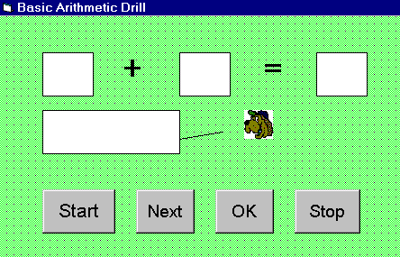
In this program, you have to draw three text boxes, three label boxes, one image box
and four command buttons.Change the of the first text box to x (text box starting from the left), second text box to y and third text box to z. Change the caption of label1 to "+"and the caption of label2 to "=".Clear the caption of label3 and change its name to display, its purpose is to show that whether the answer is wrong or correct. Now, change the caption of the four command buttons to Start, Next, OK and Stop, you may also change their names following their captions respectively.
You also need to draw a line and insert an image in the image box as shown in my program.
Now let's look at the codes:
Private Sub Stop_Click()
End
End Sub
Private Sub Text1_Change()
End Sub
Sub Start_Click()
' To get any random integers from 0 to 100
Randomize Timer
firstNum = Int(Rnd * 100) + 1
secondNum = Int(Rnd * 100) + 1
x.Text = Str$(firstNum)
y.Text = Str$(secondNum)
End Sub
Private Sub Picture1_Click ( )
End Sub
Private Sub OK_Click( )
If z.Text = x.Text + y.Text Then
display.Caption = "Correct"
Image2.Visible = "true"
Line1.Visible = "true"
Else
display.Caption = "Wrong"
Image2.Visible = "false"
Line1.Visible = "false"
End If
End Sub
Private Sub Next_Click()
z.Text = ""
display.Caption = ""
Start_Click
End Sub
if you would like the user to press the Enter key after typing the answer, write an event procedure for the keyPress event as follows:
Private Sub z_KeyPress(KeyAscii As Integer)
If (KeyAscii = 13) Then
OK_Click
End If
End Sub
where KeyAscii=13 denotes the Enter key.
After starting the program, the user (can be a teacher, parent or a child himself) have to click on the Start button. Two numbers will be presented in the first two text box. The user have to key in the answer and click OK. The user will know whether the answer is correct or wrong as it will be shown in the third label. To end, just click on the Stop button.
In this program, you may need to know what is the Rnd and Int function . Rnd return a random number between 0 and 1 while Int returns the next smallest integer of a number.
Example: if Rnd=0.7423
100*Rnd=74.23
Int(100*Rnd)=74
By combining Rnd and Int functions, you can generate random integers of any range.
The Str$ function is to convert a number to text while Val function is to convert text to number.
Please try out the above program. If you have any doubts, don't hesitate to email me.

Lesson 8 : More On Program Control

8.1 Select Case
If you have a lot of conditional statements, using If..Then..Else could be very messy. For multiple conditional statements, it is better to use Select Case
The format is :
Select Case expression
Case value1
Block of one or more VB statements
Case value2
Block of one or more VB Statements
Case value3
Block of one or more VB statements
Case value4
.
.
.
Case Else
Block of one or more VB Statements
End Select
* The data type specified in expression must match that of Case values.

8.2 Examples
Example 8.1
' Examination Grades
Dim grade As String
Private Sub Compute_Click( )
grade=txtgrade.Text
Select Case grade
Case "A"
result.Caption="High Distinction"
Case "A-"
result.Caption="Distinction"
Case "B"
result.Caption="Credit"
Case "C"
result.Caption="Pass"
Case Else
result.Caption="Fail"
End Select
*Please note that grade is a string, so all the case values such as "A" are of String data type.
Example 8.2
Dim mark As Single
Private Sub Compute_Click()
'Examination Marks
mark = mrk.Text
Select Case mark
Case Is >= 85
comment.Caption = "Excellence"
Case Is >= 70
comment.Caption = "Good"
Case Is >= 60
comment.Caption = "Above Average"
Case Is >= 50
comment.Caption = "Average"
Case Else
comment.Caption = "Need to work harder"
End Select
End Sub
* Note we use the keyword Is here to impose the conditions. This is generally used for numeric data.
Example 8.3
Example 8.2 could be rewritten as follows:
Dim mark As Single
Private Sub Compute_Click()
'Examination Marks
mark = mrk.Text
Select Case mark
Case 0 to 49
comment.Caption = "Need to work harder"
Case 50 to 59
comment.Caption = "Average"
Case 60 to 69
comment.Caption = "Above Average"
Case 70 to 84
comment.Caption = "Good"
Case Else
comment.Caption = "Excellence"
End Select
End Sub

Lesson 9: Looping
Visual Basic allows a procedure to be repeated as many times as long as the processor could support. This is generally called looping .

9.1 Do Loop
The format are
a) Do While condition
Block of one or more VB statements
Loop
b) Do
Block of one or more VB statements
Loop While condition
c) Do Until condition
Block of one or more VB statements
Loop
d) Do
Block of one or more VB statements
Loop Until condition
Example 9.1
Do while counter <=1000
num.Text=counter
counter =counter+1
Loop
* The above example will keep on adding until counter >1000.
The above example can be rewritten as
Do
num.Text=counter
counter=counter+1
Loop until counter>1000

9.2 For....Next Loop
The format is:
For counter=startNumber to endNumber (Step increment)
One or more VB statements
Next
Example:
(a) For counter=1 to 10
display.Text=counter
Next
(b) For counter=1 to 1000 step 10
counter=counter+1
Next
(c) For counter=1000 to 5 step -5
counter=counter-10
Next

Lesson 10: Introduction to VB Functions- Part I
Functions are similar to normal procedures but the main purpose of the functions is to accept certain inputs and pass them on to the main program to finish the execution. They are two types of function, the built-in functions(or internal functions) and the functions created by the programmers.
The general format of a function is
functionName(arguments)
where arguments are values that are passed on to the functions.
In this lesson, we are going to learn two very basic but useful internal functions, i.e. the MsgBox( ) and InputBox ( ) functions.

10.1 MsgBox ( ) Function
The objective of MsgBox is to produce a pop-up message box and prompt the user to click on a command button before he /she can continues. This message box format is as follows:
yourMsg=MsgBox(Prompt, Style Value, Title)
The first argument, Prompt, will display the message in the message box. The Style Value will determine what type of command buttons appear on the message box, please refer Table 10.1 for types of command button displayed. The Title argument will display the title of the message board.
Table 10.1: Style Values
Style Value | Named Constant | Buttons Displayed
0 | vbOkOnly | Ok button
1 | vbOkCancel | Ok and Cancel buttons
2 | vbAbortRetryIgnore | Abort, Retry and Ignore buttons.
3 | vbYesNoCancel | Yes, No and Cancel buttons
4 | vbYesNo | Yes and No buttons
5 | vbRetryCancel | Retry and Cancel buttons
We can use named constant in place of integers for the second argument to make the programs more readable. In fact, VB6 will automatically shows up a list of names constant where you can select one of them.
example: yourMsg=MsgBox( "Click OK to Proceed", 1, "Startup Menu")
and yourMsg=Msg("Click OK to Proceed". vbOkCancel,"Startup Menu")
are the same.
yourMsg is a variable that holds values that are returned by the MsgBox ( ) function. The values are determined by the type of buttons being clicked by the users. It has to be declared as Integer data type in the procedure or in the general declaration section. Table 10.2 shows the values, the corresponding named constant and buttons.
Table 10.2 : Return Values and Command Buttons
Value | Named Constant | Button Clicked
1 | vbOk | Ok button
2 | vbCancel | Cancel button
3 | vbAbort | Abort button
4 | vbRetry | Retry button
5 | vbIgnore | Ignore button
6 | vbYes | Yes button
7 | vbNo | No button
Example 10.1
i. The Interface:
You draw three command buttons and a label as shown in Figure 10.1
Figure 10.1
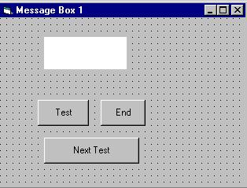
ii. The procedure for the test button:

Private Sub Test_Click()
Dim testmsg As Integer
testmsg = MsgBox("Click to test", 1, "Test message")
If testmsg = 1 Then
Display.Caption = "Testing Successful"
Else
Display.Caption = "Testing fail"
End If
End Sub
When a user click on the test button, the image like the one shown in Figure 10.2 will appear. As the user click on the OK button, the message "Testing successful" will be displayed and when he/she clicks on the Cancel button, the message "Testing fail" will be displayed.
Figure 10.2
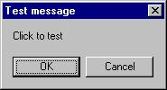

To make the message box looks more sophisticated, you can add an icon besides the message. There are four types of icons available in VB as shown in Table 10.3
Table 10.3
Value | Named Constant | Icon
16 | vbCritical | 
32 | vbQuestion | 
48 | vbExclamation | 
64 | vbInformation | 
Example 10.2
In this example, the following message box will be displayed:
Figure 10.3
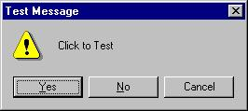
You could draw the same Interface as in example 10.1 but modify the codes as follows:
Private Sub test2_Click()
Dim testMsg2 As Integer
testMsg2 = MsgBox("Click to Test", vbYesNoCancel + vbExclamation, "Test Message")
If testMsg2 = 6 Then
display2.Caption = "Testing successful"
ElseIf testMsg2 = 7 Then
display2.Caption = "Are you sure?"
Else
display2.Caption = "Testing fail"
End If
End Sub

10.2 The InputBox( ) Function
An InputBox( ) function will display a message box where the user can enter a value or a message in the form of text. The format is
myMessage=InputBox(Prompt, Title, default_text, x-position, y-position)
myMessage is a variant data type but typically it is declared as string, which accept the message input by the users. The arguments are explained as follows:
- Prompt - The message displayed normally as a question asked.
- Title - The title of the Input Box.
- default-text - The default text that appears in the input field where users can use it as his intended input or he may change to the message he wish to key in.
- x-position and y-position - the position or the coordinate of the input box.
Example 10.3
i. The Interface
Figure 10.4
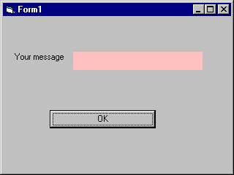

ii. The procedure for the OK button
Private Sub OK_Click()
Dim userMsg As String
userMsg = InputBox("What is your message?", "Message Entry Form", "Enter your messge here", 500, 700)
If userMsg <> "" Then
message.Caption = userMsg
Else
message.Caption = "No Message"
End If
End Sub
When a user click the OK button, the input box as shown in Figure 10.5 will appear. After user entering the message and click OK, the message will be displayed on the caption, if he click Cancel, "No message" will be displayed.
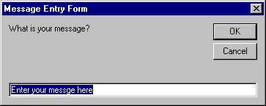

Lesson 11: Introduction to VB Functions- Part II
11.1 Creating Your Own Functions
The general format of a function is as follows:
Public Function functionName (Arg As dataType,..........) As dataType
or
Private Function functionName (Arg As dataType,..........) As dataType
* Public indicates that the function is applicable to the whole program and
Private indicates that the function is only applicable to a certain module or procedure.
Example 11.1
In this example, a user can calculate future value of a certain amount of money he has today based on the interest rate and the number of years from now supposing he will invest this amount of money somewhere). The calculation is based on the compound interest rate.
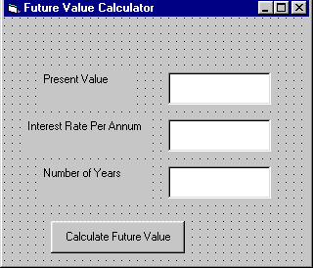
Public Function FV(PV As Variant, i As Variant, n As Variant) As Variant
'Formula to calculate Future Value(FV)
'PV denotes Present Value
FV = PV * (1 + i / 100) ^ n
End Function
Private Sub compute_Click()
'This procedure will calculate Future Value
Dim FutureVal As Variant
Dim PresentVal As Variant
Dim interest As Variant
Dim period As Variant
PresentVal = PV.Text
interest = rate.Text
period = years.Text
FutureVal = FV(PresentVal, interest, period)
MsgBox ("The Future Value is " & FutureVal)
End Sub
Example 11.2
The following program will automatically compute examination grades based on the marks that a student obtained.
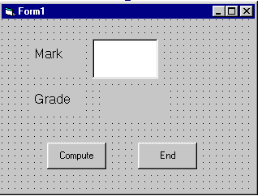
Public Function grade(mark As Variant) As String
Select Case mark
Case Is >= 80
grade = "A"
Case Is >= 70
grade = "B"
Case Is >= 60
grade = "C"
Case Is >= 50
grade = "D"
Case Is >= 40
grade = "E"
Case Else
grade = "F"
End Select
End Function
Private Sub compute_Click()
grading.Caption = grade(mark)
End Sub
Private Sub End_Click()
End
End Sub

Lesson 12: Creating VB Functions For MS Excel
12.2 The Needs to Create User-Defined Functions in MS-Excel
You can create your own functions to supplement the built-in functions in Microsoft Excel spreadsheet which are quite limited. These functions could be very useful and powerful if you know how to program them properly. One main reason we need to create user defined functions is to enable us to customize our spreadsheet environment for individual needs. For example, we might need a function that could calculate commissions payment based on the sales volume, which is quite difficult if not impossible by using the built-in function alone. Lets look at the table below:
Table 12.1: Commissions Payment Table
Sales Volume($) | Commissons
<500 | 3%
<1000 | 6%
<2000 | 9%
<5000 | 12%
>5000 | 15%
In the above table, if a saleman attain a sale volume of $6000, he will be paid $6000x12%=$720.00. A visual basic function to calculate the commissions could be written as
follows:
Function Comm(Sales_V As Variant) as Variant
If Sales_V <500 Then
Comm=Sales_V*0.03
Elseif Sales_V>=500 and Sales_V<1000 Then
Comm=Sales_V*0.06
Elseif Sales_V>=1000 and Sales_V<2000 Then
Comm=Sales_V*0.09
Elseif Sales_V>=200 and Sales_V<5000 Then
Comm=Sales_V*0.12
Elseif Sales_V>=5000 Then
Comm=Sales_V*0.15
End If
End Function
12.2 Using Microsoft Excel Visual Basic Editor
To create User Defined functions in MS Excel, you can click on tools, select macro and then click on Visual Basic Editor as shown in Figure 12.1
Figure 12.1: Inserting MS_Excel Visual Basic Editor
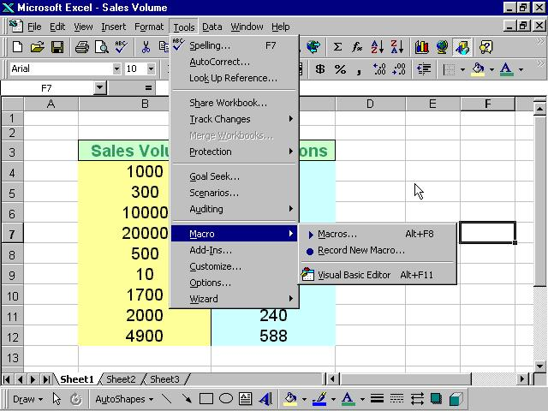
Upon clicking the Visual Basic Editor, the VB Editor windows will appear as shown in figure 12.2. To create a function, type in the function as illustrated in section 12.1 above After typing, save the
file and then return to the Excel windows.
Figure 12.2 : The VB Editor
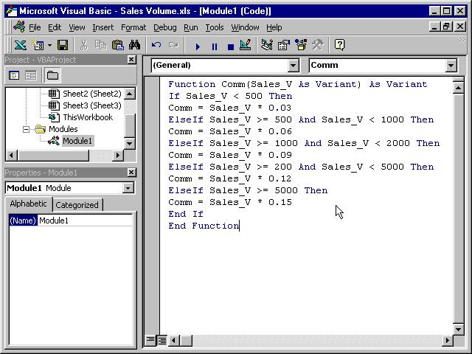
In the Excel windows, type in the titles Sales Volume and Commissions in any two cells. By referring to figure 12.3, key-in the Comm function at cell C4 and by referencing the value in cell B4, using the format Comm(B4). Any value appear in cell B4 will pass the value to the Comm function in cell C4. For the rest of the rows, just copy the formula by dragging the bottom right corner of cell C4 to the required cells, and a nice and neat table that show the commissions will automatically appear. It can also be updated anytime
Figure 12.3: MS Excel Windows- Sales Volume
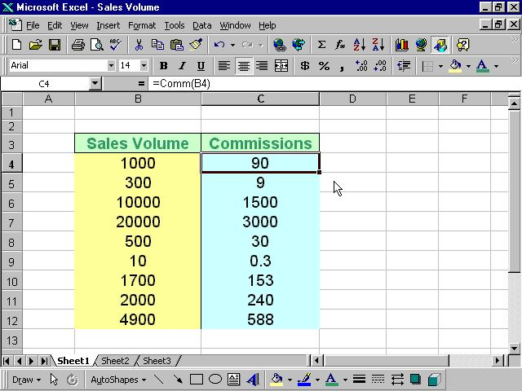

Lesson 13: Arrays

13.1 Introduction to Arrays
By definition, an array is a list of variables, all with the same data type and name. When we work with a single item, we only need to use one variable. However, if we have a list of items which are of similar type to deal with, we need to declare an array of variables instead of using a variable for each item. For example, if we need to enter one hundred names, instead of declaring one hundred different variables, we need to declare only one array. We differentiate each item in the array by using subscript, the index value of each item, for example name(1), name(2),name(3) .......etc.

13.2 Declaring Arrays
We could use Public or Dim statement to declare an array just as the way we declare a single variable. The Public statement declares an array that can be used throughout an application while the Dim statement declare an array that could be used only in a local procedure.
The general format to declare an array is as follow:
Dim arrayName(subs) as dataType
where subs indicates the last subscript in the array.
Example 13.1
Dim CusName(10) as String
will declare an array that consists of 10 elements if the statement Option Base 1 appear in the declaration area, starting from CusName(1) to CusName(10). Otherwise, there will be 11 elements in the array starting from CusName(0) through to CusName(10)
Example 13.2
Dim Count(100 to 500) as Integer
declares an array that consists of the first element starting from Count(100) and ends at Count(500)

13.3 Sample Programs
(i)
The Interface
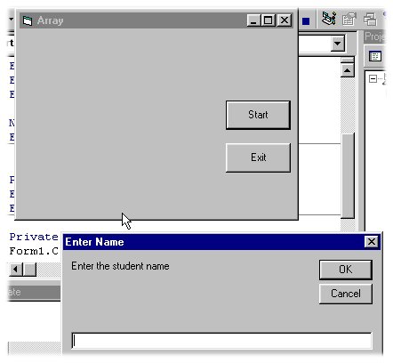
The codes
Dim studentName(10) As String
Dim num As Integer
Private Sub addName()
For num = 1 To 10
studentName(num) = InputBox("Enter the student name", "Enter Name", "", 1500, 4500)
If studentName(num) <> "" Then
Form1.Print studentName(num)
Else
End
End If
Next
End Sub
Private Sub Exit_Click()
End
End Sub
Private Sub Start_Click()
Form1.Cls
addName
End Sub
The above program accepts data entry through an input box and displays the entries in the form itself. As you can see, this program will only allows a user to enter 10 names each time he click on the start button.
(ii)
The Interface
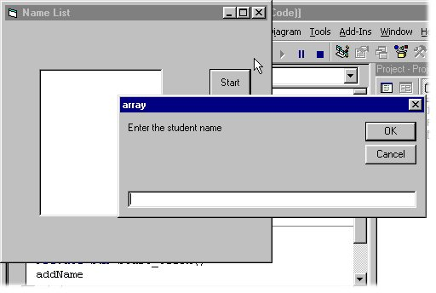
The Codes
Dim studentName(10) As String
Dim num As Integer
Private Sub addName( )
For num = 1 To 10
studentName(num) = InputBox("Enter the student name")
List1.AddItem studentName(num)
Next
End Sub
Private Sub Start_Click()
addName
End Sub
The above program accepts data entries through an InputBox and displays the items in a list box.

Lesson 14: Working with Files

14.1 Introduction
Up until lesson 13 we are only creating programs that could accept data at runtime, when a program is terminated, the data also disappear. Is it possible to save data accepted by a VB program into a storage device, such as a hard disk or diskette, or even CDRW? The answer is possible. Is this chapter, we will learn how to create files by writing them into a storage device and then retrieve the data by reading the contents of the files using customized VB programs.

14.2 Creating files
To create a file , use the following command
Open "fileName" For Output As #fileNumber
Each file created must have a file name and a file number for identification. As for file name, you must also specify the path where the file will reside.
For example
Open "c:\My Documents\sample.txt" For Output As #1
will create a text file by the name of sample.txt in the My Document folder. The accompany file number is 1. If you wish to create and save the file in A drive, simply change the path, as follows"
Open "A:\sample.txt" For Output As #1
If you wish to create a HTML file , simple change the extension to .html
Open "c:\My Documents\sample.html" For Output As # 2
14.2.1 Sample Program : Creating a text file
Private Sub create_Click()
Dim intMsg As String
Dim StudentName As String
Open "c:\My Documents\sample.txt" For Output As #1
intMsg = MsgBox("File sample.txt opened")
StudentName = InputBox("Enter the student Name")
Print #1, StudentName
intMsg = MsgBox("Writing a" & StudentName & " to sample.txt ")
Close #1
intMsg = MsgBox("File sample.txt closed")
End Sub
* The above program will create a file sample.txt in the My Documents' folder and ready to receive input from users. Any data input by users will be saved in this text file.

14.3 Reading files
To read a file created in section 14.2, you can use the input # statement. However, we can only read the file according to the format when it was written. You have to open the file according to its file number and the variable that hold the data. We also need to declare the variable using the DIM command.
14.3.1 Sample Program: Reading file
Private Sub Reading_Click()
Dim variable1 As String
Open "c:\My Documents\sample.txt" For Input As #1
Input #1, variable1
Text1.Text = variable1
Close #1
End Sub
* This program will open the sample.txt file and display its contents in the Text1 textbox.

Lesson 15: Creating Multimedia Applications-Part I
You can create various multimedia applications in VB that couold play audio CD, audiofiles, VCD , video files and etc.
To be able to play multimedia files or multimedia devices, you have to insert Microsoft Multimedia Control into your VB applications
that you are going to create. However, Microsoft Multimedia Control is not normally included in the startup toolbox, therefore you need
to add the MM control by pressing Ctrl+T and select it from the components dialog box that is displayed.
15.1 Creating a CD player
(a) The Interface.
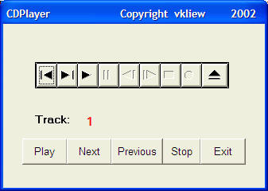
Private Sub Form_Load()
'To position the page at the center
Left = (Screen.Width - Width) \ 2
Top = (Screen.Height - Height) \ 2
'Open the CD
myCD.Command = "Open"
End Sub
Private Sub myCD_StatusUpdate()
'Update the track number
trackNum.Caption = myCD.Track
End Sub
Private Sub Next_Click()
myCD.Command = "Next"
End Sub
Private Sub Play_Click()
myCD.Command = "Play"
End Sub
Private Sub Previous_Click()
myCD.Command = "Prev"
End Sub
Private Sub Stop_Click()
myCD.Command = "Stop"
End Sub
Private Sub Exit_Click()
End
End Sub

Lesson 16: Creating Multimedia Applications-Part II
In previous lesson, we have programmed a CD player. Now, with some modifications, we will transform the CD player into an audio file player. This player will be created in such a way that it could search for wave and midi files in your drives and play them.
In this project, you need to insert a ComboBox, a DriveListBox, a DirListBox, a TextBox and a FileListBox into your form.I Shall briefly discuss the function of each of the above controls. Besides, you must also insert Microsoft Multimedia Control(MMControl) in your form , you may make it visible or invisible. In my program, I choose to make it invisible so that I could use the command buttons created to control the player.
- ComboBox- to display and enable selection of different type of files.
- DriveListBox- to allow selection selection of different drives available on your PC.
- DirListBox - To display directories
- TextBox - To display selected files
- FileListBox- To display files that are available
Relevant codes must be written to coordinate all the above controls so that the application can work properly. The program should flow in the following logical way:
Step 1: User choose the type of files he wants to play.
Step2:User selects the drive that might contains the relevant audio files.
Step 3:User looks into directories and subdirectories for the files specified in step1. The files should be displayed in the FileListBox.
Step 4: User selects the files from the FileListBox and click the Play button.
Step 5: User click on the Stop to stop playing and Exit button to end the application.
The Interface
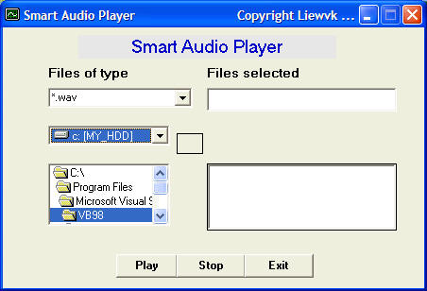
¡¡
The Code
Private Sub Combo1_Change()
' to determine file type
If ListIndex = 0 Then
File1.Pattern = ("*.wav")
ElseIf ListIndex = 1 Then
File1.Pattern = ("*.mid")
Else
Fiel1.Pattern = ("*.*")
End If
End Sub
Private Sub Dir1_Change()
'To change directories and subdirectories(or folders and subfolders)
File1.Path = Dir1.Path
If Combo1.ListIndex = 0 Then
File1.Pattern = ("*.wav")
ElseIf Combo1.ListIndex = 1 Then
File1.Pattern = ("*.mid")
Else
File1.Pattern = ("*.*")
End If
End Sub
Private Sub Drive1_Change()
'To change drives
Dir1.Path = Drive1.Drive
End Sub
Private Sub File1_Click()
If Combo1.ListIndex = 0 Then
File1.Pattern = ("*.wav")
ElseIf Combo1.ListIndex = 1 Then
File1.Pattern = ("*.mid")
Else
File1.Pattern = ("*.*")
End If
If Right(File1.Path, 1) <> "\" Then
filenam = File1.Path + "\" + File1.FileName
Else
filenam = File1.Path + File1.FileName
End If
Text1.Text = filenam
End Sub
Private Sub Form_Load()
'To center the Audioplayer startup page
Left = (Screen.Width - Width) \ 2
Top = (Screen.Height - Height) \ 2
Combo1.Text = "*.wav"
Combo1.AddItem "*.wav"
Combo1.AddItem "*.mid"
Combo1.AddItem "All files"
End Sub
Private Sub AudioPlayer_Click()
End Sub
Private Sub play_Click()
'To play WaveAudio file or Midi File
Command2_Click
If Combo1.ListIndex = 0 Then
AudioPlayer.DeviceType = "WaveAudio"
ElseIf Combo1.ListIndex = 1 Then
AudioPlayer.DeviceType = "Sequencer"
End If
AudioPlayer.FileName = Text1.Text
AudioPlayer.Command = "Open"
AudioPlayer.Command = "Play"
End Sub
Private Sub stop_Click()
If AudioPlayer.Mode = 524 Then Exit Sub
If AudioPlayer.Mode <> 525 Then
AudioPlayer.Wait = True
AudioPlayer.Command = "Stop"
End If
AudioPlayer.Wait = True
AudioPlayer.Command = "Close"
End Sub
Private Sub Exit_Click()
End
End Sub

Lesson 17: Creating Multimedia Applications-Part III
In lesson 16, we have created an audio player. Now, with some modifications, we will transform the audio player into a picture viewer. This player will be created in such a way that it could search for all types of graphics your drives and displays them.
Similar to the previous project, in this project, you need to insert a ComboBox, a DriveListBox, a DirListBox, a TextBox and a FileListBox into your form. I Shall briefly explain again the function of each of the above controls.
- ComboBox- to display and enable selection of different type of files.
- DriveListBox- to allow selection selection of different drives available on your PC.
- DirListBox - To display directories
- TextBox - To display selected files
- FileListBox- To display files that are available
Relevant codes must be written to coordinate all the above controls so that the application can work properly. The program should flow in the following logical way:
Step 1: User choose the type of files he wants to play.
Step2:User selects the drive that might contains the relevant graphic files.
Step 3:User looks into directories and subdirectories for the files specified in step1. The files should be displayed in the FileListBox.
Step 4: User selects the files from the FileListBox and click the Show button.
Step 5: User click on Exit button to end the application.
¡¡
The Interface
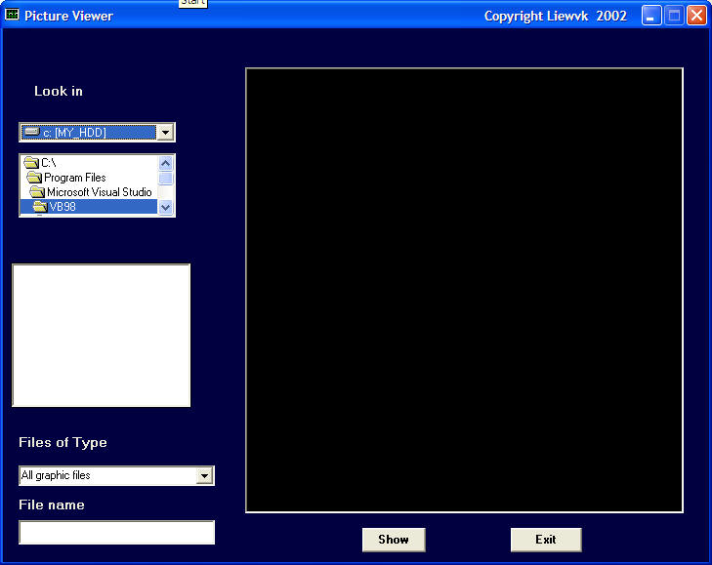
[Test run the program]
The Code
Private Sub Form_Load()
Left = (Screen.Width - Width) \ 2
Top = (Screen.Height - Height) \ 2
Combo1.Text = "All graphic files"
Combo1.AddItem "All graphic files"
Combo1.AddItem "All files"
End Sub
¡¡
Private Sub Combo1_Change()
If ListIndex = 0 Then
File1.Pattern = ("*.bmp;*.wmf;*.jpg;*.gif")
Else
Fiel1.Pattern = ("*.*")
End If
End Sub
Private Sub Dir1_Change()
File1.Path = Dir1.Path
File1.Pattern = ("*.bmp;*.wmf;*.jpg;*.gif")
End Sub
Private Sub Drive1_Change()
Dir1.Path = Drive1.Drive
End Sub
Private Sub Exit_Click()
End
End Sub
Private Sub File1_Click()
If Combo1.ListIndex = 0 Then
File1.Pattern = ("*.bmp;*.wmf;*.jpg;*.gif")
Else
File1.Pattern = ("*.*")
End If
If Right(File1.Path, 1) <> "\" Then
filenam = File1.Path + "\" + File1.FileName
Else
filenam = File1.Path + File1.FileName
End If
Text1.Text = filenam
End Sub
Private Sub play_Click()
MMPlayer.FileName = Text1.Text
End Sub
Private Sub show_Click()
If Right(File1.Path, 1) <> "\" Then
filenam = File1.Path + "\" + File1.FileName
Else
filenam = File1.Path + File1.FileName
End If
picture1.Picture = LoadPicture(filenam)
End Sub

Lesson 18: Creating Multimedia Applications-Part IV: A Multimedia Player
In lesson 16, we have created an audio player. Now, with some modifications, we will transform the audio player into a multimedia player that could play all kinds of movie files besides audio files. This player will be created in such a way that it could search for all types of graphics your drives and play them.
In this project, you need to insert a ComboBox, a DriveListBox, a DirListBox, a TextBox ,a FileListBox and a picture box(for playing movie) into your form. I Shall briefly discuss the function of each of the above controls. Besides, you must also insert Microsoft Multimedia Control(MMControl) in your form , you may make it visible or invisible. In my program, I choose to make it invisible so that I could use the command buttons created to control the player.
- ComboBox- to display and enable selection of different type of files.
- DriveListBox- to allow selection selection of different drives available on your PC.
- DirListBox - To display directories
- TextBox - To display selected files
- FileListBox- To display files that are available
Relevant codes must be written to coordinate all the above controls so that the application can work properly. The program should flow in the following logical way:
Step 1: User choose the type of files he wants to play.
Step2:User selects the drive that might contains the relevant audio files.
Step 3:User looks into directories and subdirectories for the files specified in step1. The files should be displayed in the FileListBox.
Step 4: User selects the files from the FileListBox and click the Play button.
Step 5: User click on the Stop to stop playing and Exit button to end the application.
¡¡
The Interface
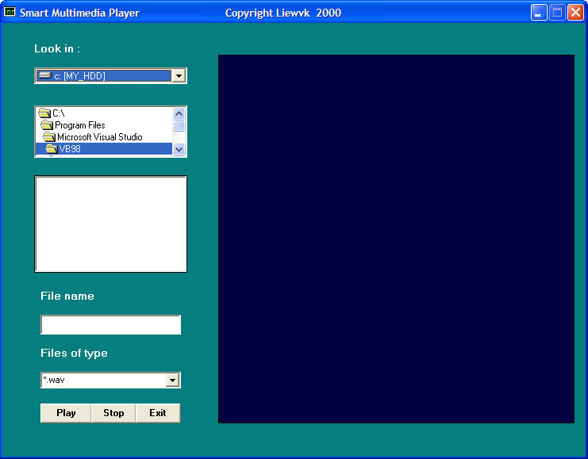
¡¡
[Test run the program]
¡¡
The Code
Private Sub Form_Load()
Left = (Screen.Width - Width) \ 2
Top = (Screen.Height - Height) \ 2
Combo1.Text = "*.wav"
Combo1.AddItem "*.wav"
Combo1.AddItem "*.mid"
Combo1.AddItem "*.avi;*.mpg"
Combo1.AddItem "All files"
End Sub
Private Sub Combo1_Change()
If ListIndex = 0 Then
File1.Pattern = ("*.wav")
ElseIf ListIndex = 1 Then
File1.Pattern = ("*.mid")
ElseIf ListIndex = 2 Then
File1.Pattern = ("*.avi;*.mpg")
Else
Fiel1.Pattern = ("*.*")
End If
End Sub
Private Sub Dir1_Change()
File1.Path = Dir1.Path
If Combo1.ListIndex = 0 Then
File1.Pattern = ("*.wav")
ElseIf Combo1.ListIndex = 1 Then
File1.Pattern = ("*.mid")
ElseIf Combo1.ListIndex = 2 Then
File1.Pattern = ("*.avi;*.mpg")
Else
File1.Pattern = ("*.*")
End If
End Sub
Private Sub Drive1_Change()
Dir1.Path = Drive1.Drive
End Sub
Private Sub Exit_Click()
End
End Sub
Private Sub File1_Click()
If Combo1.ListIndex = 0 Then
File1.Pattern = ("*.wav")
ElseIf Combo1.ListIndex = 1 Then
File1.Pattern = ("*.mid")
ElseIf Combo1.ListIndex = 2 Then
File1.Pattern = ("*.avi;*.mpg")
Else
File1.Pattern = ("*.*")
End If
If Right(File1.Path, 1) <> "\" Then
filenam = File1.Path + "\" + File1.FileName
Else
filenam = File1.Path + File1.FileName
End If
Text1.Text = filenam
End Sub
Private Sub MMPlayer_Click()
End Sub
Private Sub Picture1_Click()
End Sub
Private Sub play_Click()
MMPlayer.FileName = Text1.Text
MMPlayer.Command = "Open"
MMPlayer.Command = "Play"
MMPlayer.hWndDisplay = videoscreen.hWnd
End Sub
Private Sub stop_Click()
If MMPlayer.Mode = 524 Then Exit Sub
If MMPlayer.Mode <> 525 Then
MMPlayer.Wait = True
MMPlayer.Command = "Stop"
End If
MMPlayer.Wait = True
MMPlayer.Command = "Close"
End Sub

Lesson 19: Creating database applications in VB-Part I
Visual basic allows us to manage databases created with different database program such as MS Access, Dbase, Paradox and etc. In this lesson, we are not dealing with how to create database files but we will see how we can access database files in the VB environment.
In the following example, we will create a simple database application which enable one to browse customers' names. To create this application, insert the data control into the new form. Place the data control somewhere at the bottom of the form. Name the data control as data_navigator. To be able to use the data control, we need to connect it to any database. We can create a database file using any database application but I suggest we use the database files that come with VB6. Let select NWIND.MDB as our database file. To connect the data control to this database, double-click the DatabaseName property in the properties window and select the above file, i.e NWIND.MDB. Next, double-click on the RecordSource property to select the customers table from the database. You can also change the caption of the data control to anything but I use "Click to browse Customers" here. After that, we will place a label and change its caption to Customer Name. Last but not least, insert another label and name it as cus_name and leave the label empty as customers' names will appear here when we click the arrows on the data control. We need to bind this label to the data control for the application to work. To do this, open the label's DataSource and select data_navigator that will appear automatically. One more thing that we need to do is to bind the label to the correct field so that data in this field will appear on this label. To do this, open the DataField property and select ContactName. Now, press F5 and run the program. You should be able to browse all the customers' names by clicking the arrows on the data control.
¡¡
The Design Interface.
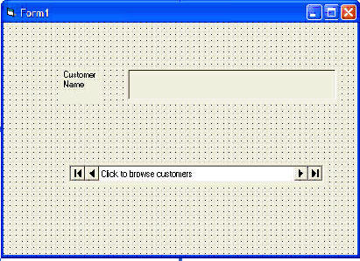
The Runtime Interface
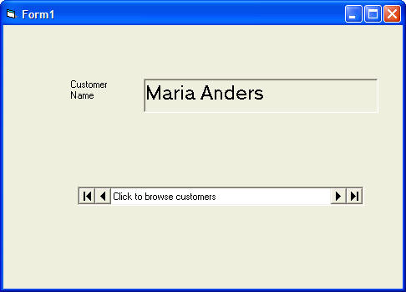
You can also add other fields using exactly the same method. For example, you can add adress, City and telephone number to the database browser.
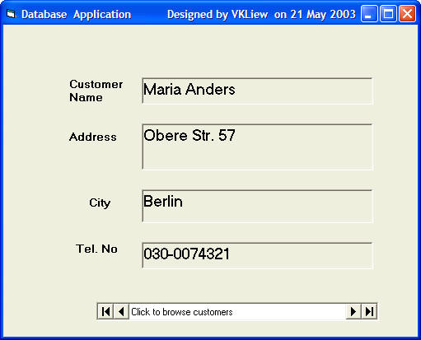

Lesson 20: Creating database applications in VB-Part II
In Lesson 19, you have learned how to create a simple database application using data control. In this lesson, you will work on the same application but use some slightly more advance commands. The data control support some methods that are useful in manipulating the database, for example, to move the pointer to a certain location. The following are some of the commands that you can use to move the pointer around.
data_navigator.RecordSet.MoveFirst ' Move to the first record
data_navigator.RecordSet.MoveLast ' Move to the last record
data_navigator.RecordSet.MoveNext ' Move to the next record
data_navigator.RecordSet.Previous ' Move to the first record
*note: data_navigator is the name of data control
¡¡
In the following example, you shall insert four commands and label them as First Record, Next Record, Previous Record and Last Record . They will be used to navigator around the database without using the data control. You still need to retain the same data control (from example in lesson 19) but set the property Visible to no so that users will not see the data control but use the button to browse through the database instead. Now, double-click on the command button and key in the codes according to the labels.
Private Sub Command2_Click()
dtaBooks.Recordset.MoveFirst
End Sub
Private Sub Command1_Click()
dtaBooks.Recordset.MoveNext
End Sub
Private Sub Command3_Click()
dtaBooks.Recordset.MovePrevious
End Sub
Private Sub Command4_Click()
dtaBooks.Recordset.MoveLast
End Sub
Run the application and you shall obtain the interface below and you will be able to browse the database using the four command buttons.
¡¡
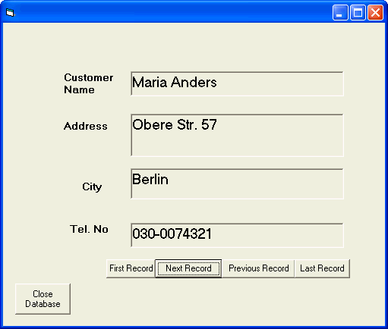

Lesson 21: Creating VB database applications using ADO control
In Lesson 19 and Lesson 20, we have learned to build VB database applications using data control. However, data control is not a very flexible tool as it could work only with limited kinds of data and must work strictly in the Visual Basic environment. To overcome these limitations, we can use a much more powerful data control in VB known as ADO control. ADO stands for ActiveX data objects. As ADO is ActiveX-based, it could work in different platforms (different computer systems) and different programming languages. Besides, it could access many different kinds of data such as data displayed in the Internet browsers, email text and even graphics other than the usual relational and non relational database information.
To be able to use ADO data control, you need to insert it into the toolbox. To do this, simply press Ctrl+T to open the components dialog box and select Microsoft ActiveX Data Control 6. After this, you can proceed to build your ADO-based VB database applications.
The following example will illustrate how to build a relatively powerful database application using ADO data control. First of all, name the new form as frmBookTitle and change its caption to Book Tiles- ADO Application. Secondly, insert the ADO data control and name it as adoBooks and change its caption to book. Next, insert the necessary labels, text boxes and command buttons. The runtime interface of this program is shown in the diagram below, it allows adding and deletion as well as updating and browsing of data.
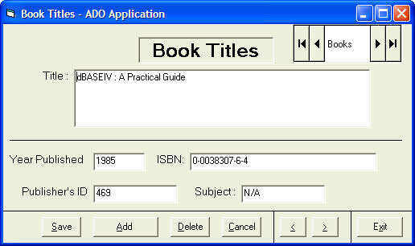
¡¡
The properties of all the controls are listed as follow:
Form Name | frmBookTitle
Form Caption | Book Titles -ADOApplication
ADO Name | adoBooks
Label1 Name | lblApp
Label1 Caption | Book Titles
Label 2 Name | lblTitle
Label2 Caption | Title :
Label3 Name | lblYear
Label3 Caption | Year Published:
Label4 Name | lblISBN
Label4 Caption | ISBN:
Labe5 Name | lblPubID
Label5 Caption | Publisher's ID:
Label6 Name | lblSubject
Label6 Caption | Subject :
TextBox1 Name | txtitle
TextBox1 DataField | Title
TextBox1 DataSource | adoBooks
TextBox2 Name | txtPub
TextBox2 DataField | Year Published
TextBox2 DataSource | adoBooks
TextBox3 Name | txtISBN
TextBox3 DataField | ISBN
TextBox3 DataSource | adoBooks
TextBox4 Name | txtPubID
TextBox4 DataField | PubID
TextBox4 DataSource | adoBooks
TextBox5 Name | txtSubject
TextBox5 DataField | Subject
TextBox5 DataSource | adoBooks
Command Button1 Name | cmdSave
Command Button1 Caption | &Save
Command Button2 Name | cmdAdd
Command Button2 Caption | &Add
Command Button3 Name | cmdDelete
Command Button3 Caption | &Delete
Command Button4 Name | cmdCancel
Command Button4 Caption | &Cancel
Command Button5 Name | cmdPrev
Command Button5 Caption | &<
Command Button6 Name | cmdNext
Command Button6 Caption | &>
Command Button7 Name | cmdExit
Command Button7 Caption | E&xit
To be able to access and manage a database, you need to connect the ADO data control to a database file. We are going to use BIBLIO.MDB that comes with VB6. To connect ADO to this database file , follow the steps below:
a) Click on the ADO control on the form and open up the properties window.
b) Click on the ConnectionString property, the following dialog box will appear.
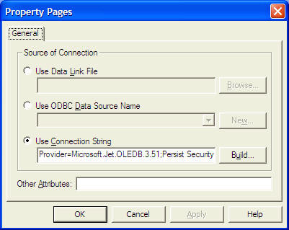
when the dialog box appear, select the Use Connection String's Option. Next, click build and at the Data Link dialog box, double-Click the option labeled Microsoft Jet 3.51 OLE DB provider.
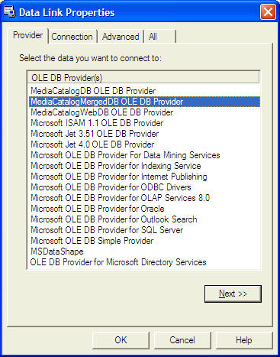
After that, click the Next button to select the file BIBLO.MDB. You can click on Text Connection to ensure proper connection of the database file. Click OK to finish the connection.
Finally, click on the RecordSource property and set the command type to adCmd Table and Table name to Titles. Now you are really to use the database file.
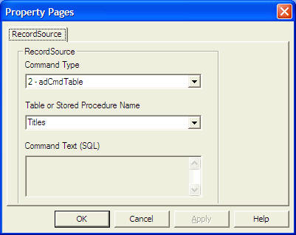
Now, you need to write code for all the command buttons. After which, you can make the ADO control invisible.
¡¡
¡¡
For the Save button, the program codes are as follow:
Private Sub cmdSave_Click()
adoBooks.Recordset.Fields("Title") = txtTitle.Text
adoBooks.Recordset.Fields("Year Published") = txtPub.Text
adoBooks.Recordset.Fields("ISBN") = txtISBN.Text
adoBooks.Recordset.Fields("PubID") = txtPubID.Text
adoBooks.Recordset.Fields("Subject") = txtSubject.Text
adoBooks.Recordset.Update
End Sub
For the Add button, the program codes are as follow:
Private Sub cmdAdd_Click()
adoBooks.Recordset.AddNew
End Sub
For the Delete button, the program codes are as follow:
Private Sub cmdDelete_Click()
Confirm = MsgBox("Are you sure you want to delete this record?", vbYesNo, "Deletion Confirmation")
If Confirm = vbYes Then
adoBooks.Recordset.Delete
MsgBox "Record Deleted!", , "Message"
Else
MsgBox "Record Not Deleted!", , "Message"
End If
End Sub
¡¡
For the Cancel button, the program codes are as follow:
Private Sub cmdCancel_Click()
txtTitle.Text = ""
txtPub.Text = ""
txtPubID.Text = ""
txtISBN.Text = ""
txtSubject.Text = ""
End Sub
For the Previous (<) button, the program codes are
Private Sub cmdPrev_Click()
If Not adoBooks.Recordset.BOF Then
adoBooks.Recordset.MovePrevious
If adoBooks.Recordset.BOF Then
adoBooks.Recordset.MoveNext
End If
End If
End Sub
For the Next(>) button, the program codes are
Private Sub cmdNext_Click()
If Not adoBooks.Recordset.EOF Then
adoBooks.Recordset.MoveNext
If adoBooks.Recordset.EOF Then
adoBooks.Recordset.MovePrevious
End If
End If
End Sub
In this sample, you will create a ADO database application to manage your home library. First of all, create a database in MS Access and name home_Library. In this database, create a table with the following field names;
Title:
Author:
Publisher:
Year:
Category:
and save the table as booktitle.mdb
¡¡
Design the Interface as follow:
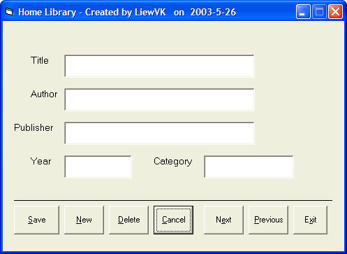
Key in the codes as follows:
Private Sub cmdCancel_Click()
txtTitle.Text = ""
txtAuthor.Text = ""
txtPublisher.Text = ""
txtYear.Text = ""
txtCategory.Text = ""
End Sub
Private Sub cmdDelete_Click()
Confirm = MsgBox("Are you sure you want to delete this record?", vbYesNo, "Deletion Confirmation")
If Confirm = vbYes Then
adoLibrary.Recordset.Delete
MsgBox "Record Deleted!", , "Message"
Else
MsgBox "Record Not Deleted!", , "Message"
End If
End Sub
Private Sub cmdExit_Click()
End
End Sub
Private Sub cmdNew_Click()
adoLibrary.Recordset.AddNew
End Sub
Private Sub cmdNext_Click()
If Not adoLibrary.Recordset.EOF Then
adoLibrary.Recordset.MoveNext
If adoLibrary.Recordset.EOF Then
adoLibrary.Recordset.MovePrevious
End If
End If
End Sub
Private Sub cmdPrevious_Click()
If Not adoLibrary.Recordset.BOF Then
adoLibrary.Recordset.MovePrevious
If adoLibrary.Recordset.BOF Then
adoLibrary.Recordset.MoveNext
End If
End If
End Sub
Private Sub cmdSave_Click()
adoLibrary.Recordset.Fields("Title") = txtTitle.Text
adoLibrary.Recordset.Fields("Author") = txtAuthor.Text
adoLibrary.Recordset.Update
End Sub

Lesson 22: Creating an Advanced VB database application using ADO control
In previous lessons, you have learned to design database applications using data control and ADO control. However, those are very simple and plain applications. In this lesson, you will learn to create a more advance database application using ADO control. The application you are going to create is known as an electronic library. This electronic library will be able to accept users' registration as well as handling login command that require the use of password, thus enhancing the security aspect of the database. Basically, the application will constitute a welcome menu, a registration menu, a Login menu and the main database menu. The sequence of the menus are illustrated as follow:
First of all, you need to design the Welcome menu. You can follow the example as follow:
Welcome
Registered Users
Registration
Login
Database

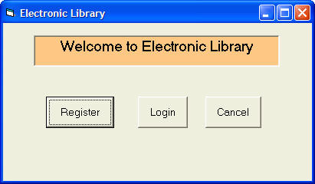
In this form, you need to insert three command buttons and set their properties as follow:
Form name | main_menu
command button 1 Name | cmdRegister
command button 1 Caption | Register
command button 2 Name | cmdLogin
command button 2 Caption | Login
command button 3 Name | cmdCancel
command button 3 Caption | Cancel
The codes are as follow:
Private Sub cmdCancel_Click()
End
End Sub
Private Sub cmdLogin_Click()
main_menu.Hide
Login_form.Show
End Sub
Private Sub cmdRegister_Click()
main_menu.Hide
Register.Show
End Sub
If a new user click the Register button, the registration form will appear. An example is illustrated as follow:
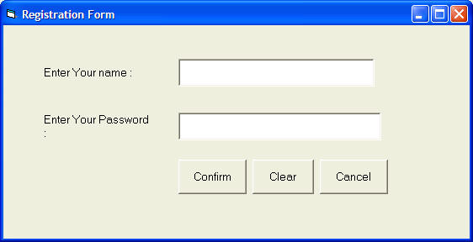
This registration forms consist of two text boxes , three command buttons and an ADO control. Their properties are set as follow:
Form name | Register
textbox 1 name | txtName
textbox 2 name | txtpassword
textbox 2 PasswordChar | *
command button 1 name | cmdConfirm
command button 1 Caption | Confirm
command button 2 name | cmdClear
command button 2 Caption | Clear
command button 3 name | cmdCancel
command button 3 Caption | Cancel
ADO control name | UserInfo
note that the PasswordChar of textbox 2 is set as * which means users will not be able to see the actual characters they enter, they will only see the * symbol.
The codes are as follow:
Private Sub cancel_Click( )
End
End Sub
Private Sub cmdClear_Click( )
txtName.Text = ""
txtpassword.Text = ""
End Sub
Private Sub cmdConfirm_Click()
UserInfo.Recordset.Fields("username") = txtName.Text
UserInfo.Recordset.Fields("password") = txtpassword.Text
UserInfo.Recordset.Update
Register.Hide
Login_form.Show
End Sub
Private Sub Form_Load()
UserInfo.Recordset.AddNew
End Sub
¡¡
The Login menu is illustrated as follow:
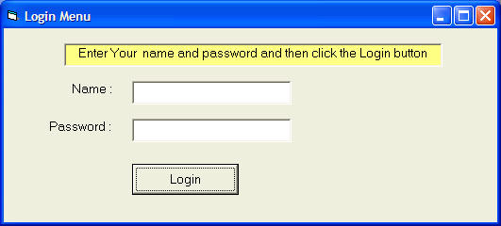
There are two text boxes and a command button, their properties are set as follow:
Textbox 1 name | txtName
Textbox 2 name | txtpassword
Command button 1 name | cmdLogin
Command button 1 Caption | Login
Form name | Login_form
The codes are as follow:
Private Sub cmdLogin_Click()
Dim usrname As String
Dim psword As String
Dim usernam As String
Dim pssword As String
Dim Msg As String
Register.UserInfo.Refresh
usrname = txtName.Text
psword = txtpassword.Text
Do Until Register.UserInfo.Recordset.EOF
If Register.UserInfo.Recordset.Fields("username").Value = usrname And Register.UserInfo.Recordset.Fields("password").Value = psword Then
Login_form.Hide
frmLibrary.Show
Exit Sub
Else
Register.UserInfo.Recordset.MoveNext
End If
Loop
Msg = MsgBox("Invalid password, try again!", vbOKCancel)
If (Msg = 1) Then
Login_form.Show
txtName.Text = ""
txtpassword = ""
Else
End
End If
End Sub
¡¡
The main database menu is illustrated as follow:
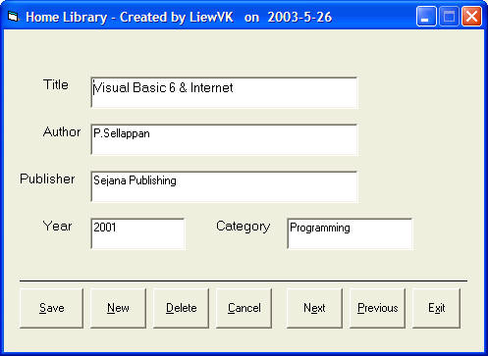
The properties of all controls are listed in the table below:
¡¡
Form name | frmLibrary
ADO control name | adoLibrary
ADO visible | False
TextBox 1 name | txtTitleA
TextBox 2 name | txtAuthor
TextBox 3name | txtPublisher
TextBox 4 name | txtYear
TextBox 5 name | txtCategory
Command button 1 name | cmdSave
Command button 1 caption | &Save
Command button 2 name | cmdNew
Command button 2 caption | &New
Command button 3 name | cmdDelete
Command button 3 caption | &Delete
Command button 4 name | cmdCancel
Command button 4 caption | &Cancel
Command button 5 name | cmdNext
Command button 5 caption | N&ext
Command button 6 name | cmdPrevious
Command button 6 caption | &Previous
Command button 7 name | cmdExit
Command button 7 caption | E&xit
¡¡
The codes are as follow:
¡¡
Private Sub cmdCancel_Click()
txtTitle.Text = ""
txtAuthor.Text = ""
txtPublisher.Text = ""
txtYear.Text = ""
txtCategory.Text = ""
End Sub
Private Sub cmdDelete_Click()
Confirm = MsgBox("Are you sure you want to delete this record?", vbYesNo, "Deletion Confirmation")
If Confirm = vbYes Then
adoLibrary.Recordset.Delete
MsgBox "Record Deleted!", , "Message"
Else
MsgBox "Record Not Deleted!", , "Message"
End If
End Sub
Private Sub cmdExit_Click()
End
End Sub
Private Sub cmdNew_Click()
adoLibrary.Recordset.AddNew
End Sub
Private Sub cmdNext_Click()
If Not adoLibrary.Recordset.EOF Then
adoLibrary.Recordset.MoveNext
If adoLibrary.Recordset.EOF Then
adoLibrary.Recordset.MovePrevious
End If
End If
End Sub
Private Sub cmdPrevious_Click()
If Not adoLibrary.Recordset.BOF Then
adoLibrary.Recordset.MovePrevious
If adoLibrary.Recordset.BOF Then
adoLibrary.Recordset.MoveNext
End If
End If
End Sub
Private Sub cmdSave_Click()
adoLibrary.Recordset.Fields("Title").Value = txtTitle.Text
adoLibrary.Recordset.Fields("Author").Value = txtAuthor.Text
adoLibrary.Recordset.Update
End Sub

Lesson 23 : Animation-Part I

Animation is always an interesting and exciting part of programming. Although visual basic is not designed to handle advance animations, you can still create some interesting animated effects if you put in some hard thinking. There are many ways to create animated effects in VB6, but for a start we will focus on some easy methods.
The simplest way to create animation is to set the VISIBLE property of a group of images or pictures or even texts and labels to true or false by triggering a set of events such as clicking a button. Let's examine the following example:
This is a program that create the illusion of moving the jet plane in four directions, North, South ,East, West. In order to do this, insert five images of the same picture into the form. Set the visible property of the image in the center to be true while the rest set to false. On start-up, a user will only be able to see the image in the center. Next, insert four command buttons into the form and change the labels to Move North, Move East, Move West and Move South respectively. Double click on the move north button and key in the following procedure:
Sub Command1_click( )
Image1.Visible = False
Image3.Visible = True
Image2.Visible = False
Image4.Visible = False
Image5.Visible = False
End Sub
By clicking on the move north button, image1 and other images except image 3 displayed. This will give an illusion that the jet plane has moved north. Key in similar procedures by double clicking other command buttons. You can also insert an addition command button and label it as Reset and key in the following codes:
Image1.Visible = True
Image3.Visible = False
Image2.Visible = False
Image4.Visible = False
Image5.Visible = False
Clicking on the reset button will make the image in the center visible again while other images become invisible, this will give the false impression that the jet plane has move back to the original position.
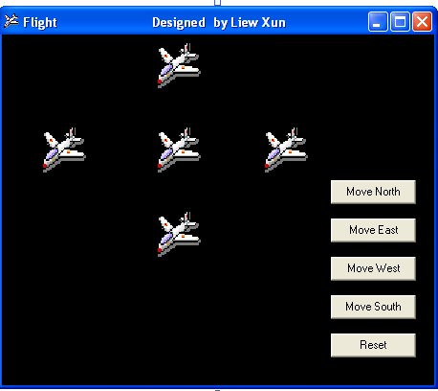
You can also issue the commands using a textbox, this idea actually came from my son Liew Xun (10 years old). His program is shown below:
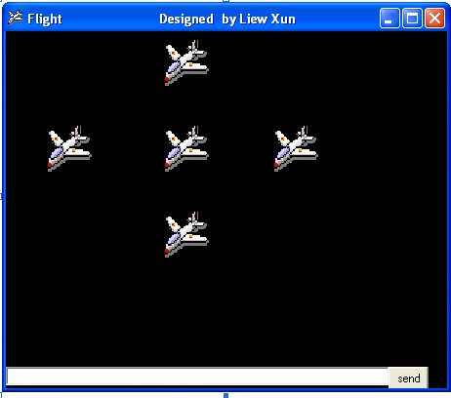
In the textbox, when you key in the letter n, the plane will move north, move west when you key in w, move south when you key in s and move east when you key in the letter e. The codes are as follows
Private Sub Command1_Click()
If Text1.Text = "n" Then
Image1.Visible = False
Image3.Visible = True
Image2.Visible = False
Image4.Visible = False
Image5.Visible = False
ElseIf Text1.Text = "e" Then
Image1.Visible = False
Image4.Visible = True
Image2.Visible = False
Image3.Visible = False
Image5.Visible = False
ElseIf Text1.Text = "w" Then
Image1.Visible = False
Image3.Visible = False
Image2.Visible = False
Image4.Visible = False
Image5.Visible = True
ElseIf Text1.Text = "s" Then
Image1.Visible = False
Image3.Visible = False
Image2.Visible = True
Image4.Visible = False
Image5.Visible = False
End If
End Sub
Another simple way to simulate animation in VB6 is by using the Left and Top properties of an object. Image.Left give the distance of the image in twips from the left border of the screen, and Image.Top give the distance of the image in twips from the top border of the screen, where 1 twip is equivalent to 1/1440 inch. Using a statement such as Image.Left-100 will move the image 100 twips to the left, Image.Left+100 will move the image 100 twip away from the left(or 100 twips to the right), Image.Top-100 will move the image 100 twips to the top and Image.Top+100 will move the image 100 twips away from the top border (or 100 twips down).
Below is a program that can move an object up, down. left, and right every time you click on a relevant command button. The code such as Image1.Top = Image1.Top + 100 is to make the distance increase or decrease every time a user click on the command button. For example, if the initial position of image1 is 1000 twip from the top, after one click, the distance from the top will be 1100, and the next distance will be 1200 and so on. Therefore, by writing similar codes for all the four buttons, you can move the image in four directions by clicking the any of the four buttons.
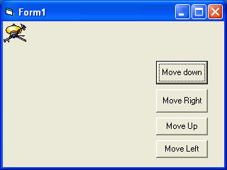
The Codes
Private Sub Command1_Click()
Image1.Top = Image1.Top + 100
End Sub
Private Sub Command2_Click()
Image1.Top = Image1.Top - 100
End Sub
Private Sub Command3_Click()
Image1.Left = Image1.Left + 100
End Sub
Private Sub Command4_Click()
Image1.Left = Image1.Left - 100
End Sub
The fourth example let user magnify and diminish an object by changing the height and width properties of an object. It is quite similar to the previous example. The statements Image1.Height = Image1.Height + 100 and Image1.Width = Image1.Width + 100 will increase the height and the width of an object by 100 twips each time a user click on the relevant command button. On the other hand, The statements Image1.Height = Image1.Height - 100 and Image1.Width = Image1.Width -100 will decrease the height and the width of an object by 100 twips each time a user click on the relevant command button
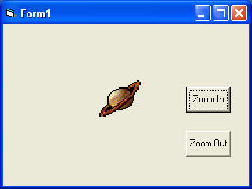
The Codes
Private Sub Command1_Click()
Image1.Height = Image1.Height + 100
Image1.Width = Image1.Width + 100
End Sub
Private Sub Command2_Click()
Image1.Height = Image1.Height - 100
Image1.Width = Image1.Width - 100
End Sub
You can try to combine both programs above and make an object move and increase or decrease in size each time a user click a command button.

Lesson 24: Animation - Part II

24.1 Animation using a drag_drop procedure.
Drag and drop is a common windows application where you can drag and drop an object such as a file into a folder or into a recycle bin. This capability can be easily programmed in visual basic. In the following example, I am creating a simulation of dragging the objects into a recycle bin, then drop a fire and burn them.
In this program, I put 6 images on the form, one of them is a recycle bin, another is a burning recycle , one more is the fire, and three more images are to be dragged into the recycle bin. Set In addition, set all the dragmode of the images( including the fire) to be dragged to 1(Automatic) so that dragging is enabled, and set the visible property of burning recycle bin to false at start-up. Besides, label the tag of fire as fire in its properties windows. If you want to have better dragging effects, you need to load an appropriate icon under the dragIcon properties for those images to be dragged, preferably the icon should be the same as the image so that when you drag the image, it is like you are dragging the image along.
The essential event procedure in this program is as follows:
Private Sub Image4_DragDrop(Source As Control, X As Single, Y As Single)
Source.Visible = False
If Source.Tag = "Fire" Then
Image4.Picture = Image5.Picture
End If
End Sub
Source refer to the image to be dragged. Using the code Source.Visible=False means it will disappear after being dragged into the recycle bin(Image4).If the source is Fire, then the recycle will changed into a burning recycle bin , which is accomplished by using the code Image4.Picture = Image5.Picture, where Image 5 is the burning recycle bin.
For details of this program, please refer to my game and fun programming page or click this link, Recycle Bin.
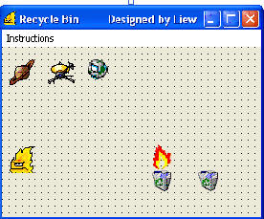

24.2 Animation for a complete motion.
So far those examples of animation shown in lesson 23 only involve movement of static images. In this lesson, you will be able to create true animation where an action finish in a complete cycle, for example, a butterfly flapping its wings. In the following example, I used eight picture frames of a butterfly which display a butterfly flapping its wing at different stages.

You can actually copy the above images and use them in your program. You need to put all the above images overlapping one another, make image1 visible while all other images invisible at start-up. Next, insert a command button and label it as Animate. Click on the command button and key in the statements that make the images appear and disappear successively by using the properties image.visible=true amd image.visible=false. I use If..... Then and Elseif to control the program flow. When you run the program, you should be able to get the following animation.
.

The Interface
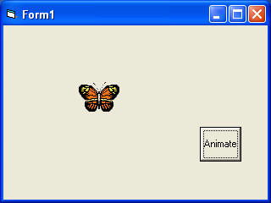

The Codes
Private Sub Command1_Click()
If Image1.Visible = True Then
Image1.Visible = False
Image2.Visible = True
ElseIf Image2.Visible = True Then
Image2.Visible = False
Image3.Visible = True
ElseIf Image3.Visible = True Then
Image3.Visible = False
Image4.Visible = True
ElseIf Image4.Visible = True Then
Image4.Visible = False
Image5.Visible = True
ElseIf Image5.Visible = True Then
Image5.Visible = False
Image6.Visible = True
ElseIf Image6.Visible = True Then
Image6.Visible = False
Image7.Visible = True
ElseIf Image7.Visible = True Then
Image7.Visible = False
Image8.Visible = True
ElseIf Image8.Visible = True Then
Image8.Visible = False
Image1.Visible = True
End If
End Sub
If you wish to create the effect of the butterfly flapping its wing and flying at the same time, then you could use the Left and Top properties of an object, such as the one used in the examples of lesson 23. Below is an example of a subroutine where the butterfly will flap its wing and move up at the same time. You can also write subroutines that move the butterfly to the left, to the right and to the bottom.
Sub move_up( )
If Image1.Visible = True Then
Image1.Visible = False
Image2.Visible = True
Image2.Top = Image2.Top - 100
ElseIf Image2.Visible = True Then
Image2.Visible = False
Image3.Visible = True
Image3.Top = Image3.Top - 100
ElseIf Image3.Visible = True Then
Image3.Visible = False
Image4.Visible = True
Image4.Top = Image4.Top - 100
ElseIf Image4.Visible = True Then
Image4.Visible = False
Image5.Visible = True
Image5.Top = Image5.Top - 100
ElseIf Image5.Visible = True Then
Image5.Visible = False
Image6.Visible = True
Image6.Top = Image6.Top - 100
ElseIf Image6.Visible = True Then
Image6.Visible = False
Image7.Visible = True
Image7.Top = Image7.Top - 100
ElseIf Image7.Visible = True Then
Image7.Visible = False
Image8.Visible = True
Image8.Top = Image8.Top - 100
ElseIf Image8.Visible = True Then
Image8.Visible = False
Image1.Visible = True
Image1.Top = Image1.Top - 100
End If
End Sub

Lesson 25: Animation - Part III

25.1 Animation using timer
All preceding examples of animation that you have learn in lesson 23 and lesson 24 only involve manual animation, which means you need to keep on clicking a certain command button or pressing a key to make an object animate. In order to make it move automatically, you need to use a timer. The first step in creating automatic animation is to drag the timer from the toolbox into the form and set its interval to a certain value other than 0. A value of 1 is 1 milliseconds which means a value of 1000 represents 1 second. The value of the timer interval will determine the speed on an animation.
In the following example, I use a very simple technique to show animation by using the properties Visible=False and Visible=true to show and hide two images alternately. When you click on the program, you should see the following animation.
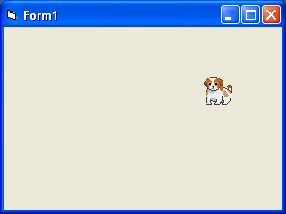

The Codes
Private Sub Timer1_Timer()
If Image1.Visible = True Then
Image1.Visible = False
Image2.Visible = True
ElseIf Image2.Visible = True Then
Image2.Visible = False
Image1.Visible = True
End If
End Sub
Next example shows a complete cycle of a motion such as the butterfly flapping its wing. Previous examples show only manual animation while this example will display an automatic animation once you start the program or by clicking a command button. Similar to the example under lesson 24.2, you need to insert a group of eight images of a butterfly flapping its wings at different stages. Next, insert a timer into the form and set the interval to 10 or any value you like. Remember to make image1 visible while other images invisible at start-up. Finally, insert a command button, rename its caption as Animate and key in the following statements by double clicking on this button. Bear in mind that you should enter the statements for hiding and showing the images under the timer1_timer subroutine otherwise the animation would work. Clicking on the animate button make timer start ticking and the event will run after every interval of 10 milliseconds or whatever interval you have set at design time. In future lesson, I will show you how to adjust the interval at runtime by using a slider bar or a scroll bar. When you run the program, you should see the following animation:
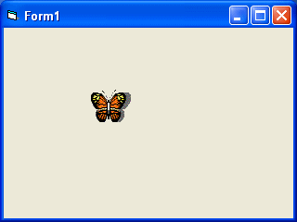

Private Sub Form_Load()
Image1.Visible = True
x = 0
End Sub
Private Sub Command1_Click()
Timer1.Enabled = True
End Sub
Private Sub Timer1_Timer()
If Image1.Visible = True Then
Image1.Visible = False
Image2.Visible = True
ElseIf Image2.Visible = True Then
Image2.Visible = False
Image3.Visible = True
ElseIf Image3.Visible = True Then
Image3.Visible = False
Image4.Visible = True
ElseIf Image4.Visible = True Then
Image4.Visible = False
Image5.Visible = True
ElseIf Image5.Visible = True Then
Image5.Visible = False
Image6.Visible = True
ElseIf Image6.Visible = True Then
Image6.Visible = False
Image7.Visible = True
ElseIf Image7.Visible = True Then
Image7.Visible = False
Image8.Visible = True
ElseIf Image8.Visible = True Then
Image8.Visible = False
Image1.Visible = True
End If
End Sub

Animated Slot Machine
This program is very similar to VB slot machine but I have added a timer and a subprogram to create the animation effect. Further, I have added the Multimedia control to produce the sound effects. I have downloaded two slot machine wave files from the Internet and use them to simulate the spinning sound and the Jackpot sound. To include the multimedia control as one of the tools, click on project on the menu and select components, then click on Microsoft Multimedia Control 6.0. Drag the MM Control into your form and make it invisible at startup. I use two MM controls, one for playing the spinning sound and the other for the jackpot sound. Always reset the MM control by setting the statement
MMControl1.Command = "Close"
The Interface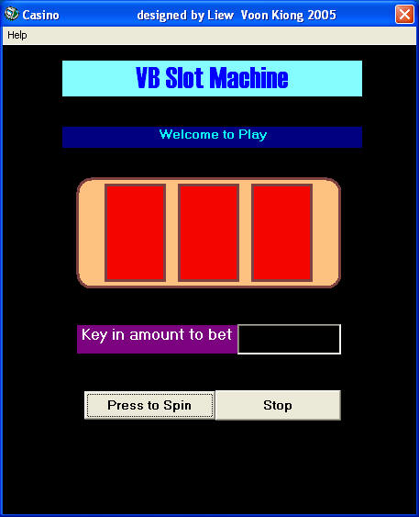

The codes
Dim x As Integer
Dim amount As Integer
Dim a, b, c As Integer
Private Sub Command1_Click()
Timer1.Enabled = True
MMControl1.Command = "Close"
MMControl2.Command = "close"
x = 0
Label2.Caption = "Your Credits"
amount = Val(Text1)
End Sub
Private Sub Command2_Click()
End
End Sub
Private Sub Form_Click()
Label3.Visible = False
End Sub
Private Sub Form_Load()
Label1.Caption = " Welcome to Play"
Label3.Visible = False
End Sub
Private Sub instruct_click()
Label3.Visible = True
End Sub
Private Sub Text1_Change()
amount = Val(Text1)
End Sub
Private Sub Timer1_Timer()
If x < 500 Then
spin
Else
Timer1.Enabled = False
MMControl1.Command = "Stop"
Label1.Alignment = 2
If (a = 3 And b = 3 And c <> 3) Or (a = 3 And c = 3 And b <> 3) Or (b = 3 And c = 3 And a <> 3) Then
Label1.Caption = " You win 20 dollars"
amount = amount + 20
End If
If (a = 4 And b = 4 And c <> 4) Or (a = 4 And c = 4 And b <> 4) Or (b = 4 And c = 4 And a <> 4) Then
Label1.Caption = " You win 30 dollars"
amount = amount + 30
End If
If (a = 5 And b = 5 And c <> 5) Or (a = 5 And c = 5 And b <> 5) Or (b = 5 And c = 5 And a <> 5) Then
Label1.Caption = " You win 40 dollars"
amount = amount + 40
End If
If (a = 3 And b = 3 And c = 3) Or (a = 4 And b = 4 And c = 4) Or (a = 5 And b = 5 And c = 5) Then
MMControl2.Notify = False
MMControl2.Wait = True
MMControl2.Shareable = False
MMControl2.DeviceType = "WaveAudio"
MMControl2.FileName = "D:\Liew Folder\VB program\audio\endgame.wav"
MMControl2.Command = "Open"
MMControl2.Command = "Play"
Label1.Caption = " Congratulation! Jackpot!!! You win 200 dollars!"
amount = amount + 200
End If
If (a = 3 And b = 4 And c = 5) Or (a = 3 And b = 5 And c = 4) Or (a = 4 And b = 3 And c = 5) Or (a = 4 And b = 5 And c = 3) Or (a = 5 And b = 4 And c = 3) Or (a = 5 And b = 3 And c = 4) Then
Label1.Caption = " Too bad, you lost 50 dollars"
amount = amount - 50
End If
If amount < 0 Then
Label1.Caption = "Oh! you're bankrupt!"
End If
Text1.Text = Str$(amount)
End If
End Sub
Sub spin( )
x = x + 10
Randomize Timer
a = 3 + Int(Rnd * 3)
b = 3 + Int(Rnd * 3)
c = 3 + Int(Rnd * 3)
MMControl1.Notify = False
MMControl1.Wait = True
MMControl1.Shareable = False
MMControl1.DeviceType = "WaveAudio"
MMControl1.FileName = "D:\Liew Folder\VB program\audio\slot2.wav"
MMControl1.Command = "Open"
MMControl1.Command = "Play"
Label1.Caption = "Good Luck!"
Label1.Alignment = a - 3
Shape1(0).Shape = a
If a = 3 Then
Shape1(0).FillColor = &HFF00&
End If
If a = 4 Then
Shape1(0).FillColor = &HFF00FF
End If
If a = 5 Then
Shape1(0).FillColor = &HFF0000
End If
Shape1(1).Shape = b
If b = 3 Then
Shape1(1).FillColor = &HFF00&
End If
If b = 4 Then
Shape1(1).FillColor = &HFF00FF
End If
If b = 5 Then
Shape1(1).FillColor = &HFF0000
End If
Shape1(2).Shape = c
If c = 3 Then
Shape1(2).FillColor = &HFF00&
End If
If c = 4 Then
Shape1(2).FillColor = &HFF00FF
End If
If c = 5 Then
Shape1(2).FillColor = &HFF0000
End If
End Sub

